My name is Emmanuel Olanrewaju, my thesis is on explainable AI with visual analytics. AI is a quickly emerging field that is having a significant impact on several sectors in the industry. It is to the extent that we now seek to manage and regulate it, so we don’t over rely on it. Before we can regulate it, we need to understand it. Most AI models are “black box”, meaning there is no way of seeing how it comes to its decision.

Emerging AI and not understanding
There are Gaps in the industry and academia with AI
Visual analytics is a viable option to explain AI
How can the XAI-Visual analytics system be developed

HardVis is primarily a visualization algorithm/methodology

Visual Analytics for Explainable and Trustworthy AI (https://ieeexplore.ieee.org/abstract/document/11033407)
To first define what trust in AI is, the author proposes a more detailed, multilevel model of trust in AI that consists of five trust levels:
- the raw data (TL1: source reliability and transparent collection process),
- the processed data (TL2: uncertainty awareness, equality/data bias, comparison of structures, guidance/recommendation, and outlier detection),
- the algorithm/learning method (TL3: familiarity, understanding/ explanation, debugging/diagnosis, refinement/steering, comparison, knowledgeability, and fairness),
- the concrete model(s) for a particular task (TL4: experience, in situ comparison, performance, what–if hypotheses, model bias, and model variance)
- The evaluation and the subjective users’ expectations (TL5: agreement of colleagues, visualization evaluation, metrics validation/results, and user bias).

What is HardVis?
HardVis is a hybrid dimensionality reduction and visualization approach that combines the strengths of different techniques to provide more reliable and interpretable visualizations of high-dimensional data.
Core Concept
HardVis explicitly separates the visualization process into two complementary components:
  - Hard (Certain) Relationships - Clear, unambiguous neighbor relationships
  - Soft (Uncertain) Relationships - Ambiguous or probabilistic relationships
The Problem HardVis Solves
Traditional methods like t-SNE have limitations:
  - t-SNE: Excellent at preserving local structure but distorts global structure
  - UMAP: Better at global structure but can oversimplify local relationships
  - PCA: Preserves global structure but misses non-linear patterns
HardVis addresses: The uncertainty in neighborhood relationships that gets lost in traditional visualizations.

HardVis: The Core Algorithm
HardVis is primarily a visualization algorithm/methodology, not an interactive application. In its basic research implementation, it typically produces:
  - Static visualizations (PNG, PDF outputs)
  - Dual-view plots (H-View and S-View)
  - Academic paper-ready figures
  - Batch processing of datasets
FeatureEnV- Feature engineeringi?? VisEvol-Hyperparameter tuning? VisRuler??? T-SNE/UMAP? Hardvis??
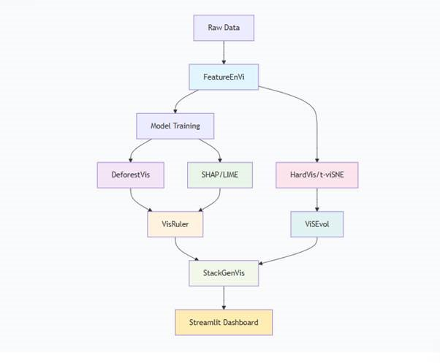

Tool | Primary Role | Explanation Level | Best For
FeatureEnVi | Feature engineering visualization | Global + Feature-level | Understanding feature spaces
Visevol | Model evolution tracking | Temporal + Global | Model lifecycle monitoring
VisRuler | Rule extraction & visualization | Local + Global | Transparent rule-based explanations
DeforestVis | Tree ensemble interpretation | Model-level | Random Forest internal workings
HardVis | Uncertainty-aware visualization | Global | Data relationship confidence
SHAP | Feature attribution | Local + Global | Quantitative feature importance

Tool | Primary Explainability Value | Best For
FeatureEnVi | Transparent feature selection | Justifying input variables
ViSEvol | Models change justification for evolutionary algorithms | Explaining model updates
VisRuler | Rule-based reasoning | Regulatory compliance
HardVis | Uncertainty quantification | Risk assessment
DeforestVis | Ensemble transparency | Complex model debugging
SHAP/LIME | Prediction attribution | Individual case explanations
Streamlit | Explanation delivery | Stakeholder communication

  - Pre-modeling: Use FeatureEnVi to justify feature selection
  - Training: Use DeforestVis to understand model architecture
  - Validation: Use VisRuler to extract human-readable rules
  - Analysis: Use t-SNE/UMAP/HardVis to understand data relationships
  - Prediction: Use SHAP/LIME to explain individual decisions
  - Monitoring: Use ViSEvol to track model changes
  - Delivery: Use Streamlit to communicate all explanations

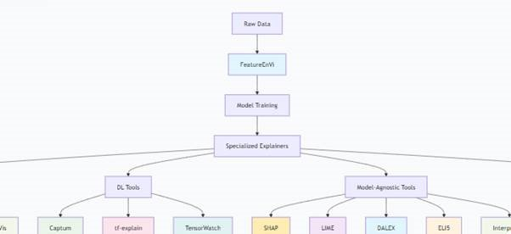

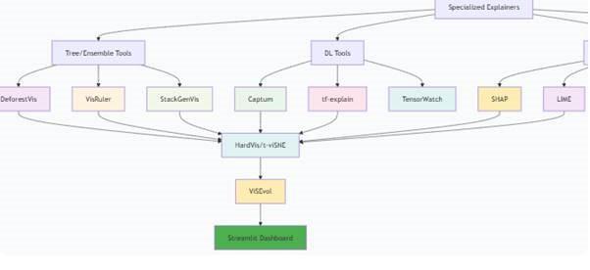

  - Deep tree/ensemble analysis (DeforestVis, VisRuler)
  - Feature engineering justification (FeatureEnVi)
  - Data structure exploration (HardVis/t-viSNE)
  - Model evolution tracking (ViSEvol)
  - Complex ensemble architectures (StackGenVis)
This Paper explored several VIS methods the show the structure of AI models, compared to prior research do there was an emphasis on the structure of AI to be explored, several models and their shortcomings were stated. I was curious If the VI models and XAI models can be used in ensemble to produce more robust explanations, thus overcoming their shortcomings.
A survey of visual analytics for Explainable Artificial Intelligence methods
https://www.sciencedirect.com/science/article/pii/S0097849321001886 While AI Interpretability and explainability are two different things, interpretability is understanding how the decision/prediction is given by machine learning algorithms, while explainability is related to the inner working mechanisms of black-box models.
Intrinsic explanation: explanation that is reliant on the system, provided by the system itself and post-hoc explanations: reveal the internal working of a system, and can be used with either a pretrained model or complete model.
Model-specific and Model-agnostic explanations: Model specific can be used for only specific algorithms or models, while model-agnostic works on any model.
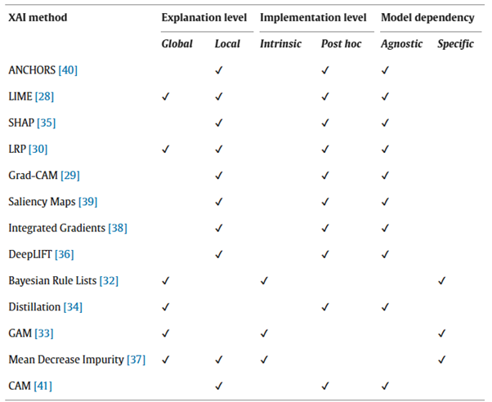

LIME provides explanation locally by approximating complex models via surrogate models
SHAP adopts strategies of game theory and treats features as team members of a game. It calculates their relative contribution of each feature as a team member of a game.
With intrinsic and post hoc models for explainability and interpretation, we can see an increase in models’ predictive ability as we move from intrinsic models to post hoc. Hence there’s a trade-off of accuracy and explainability as models move from glass box to black box. Hence for more complex black box models we’ll be making use of model

Agnostic techniques, along with scalability, are major issues facing AI explainability.
Layer-wise Relevance Propagation (Most Common in Tech/AI)
This is a highly prominent technique, especially in the field of Explainable AI (XAI).

LRP: Provides explanation for deep neural networks by propagating the prediction backward in the network, where inputs can be of different formats.

    - What it is: A method used to understand the predictions of complex machine learning models, particularly deep neural networks. It "explains" a model's decision by attributing relevance scores to each input feature (e.g., pixels in an image, words in a text).
    - How it works: It works backwards from the model's output to its input. It takes the prediction score (e.g., "90% confident this is a cat") and redistributes this relevance layer-by-layer through the network until it reaches the input pixels. The result is a heatmap that highlights which parts of the input were most important for the decision.

Anchors: make use of Rule-based IF-THEN to explain predictions, The idea is to find an anchor or definitive characteristic that leads to the prediction. For instance, if the image has whiskers, then it is a cat.

Saliency maps: are gradient based explanation methods that calculate feature importance based on gradients and visualize and highlight important pixels or words that contribute to the final convolution network.

Class Activation mapping (CAM): This is another Gradient-based method focused on interpreting the prediction of convolution networks. Grad-CAM is a highly class-discriminative method that uses the gradients of any class concept. It flows gradients into the final layer to create a heat-map that highlights the significant pixels for classifying the related concept.

From my studies it appears most of the models in this are more interpretable AI, rather than an explainable AI. They explain the result and what portion of it is important but don’t necessarily explain the inner workings of the black box AI systems.

Model distillation method is a compression technique used to obtain an interpretable model, by transferring knowledge from a pretrained DNN, called teacher model, to small networks called student. The student replicates the structure of the teacher model but appears more explainable.

DeepLIFT: is an explanation method that computes the importance of values of features in NN models. It propagates a ‘reference point’ to obtain a reference output. Activation neurons are compared with reference activation, then important scores are allocated.

INTEGRATED GRADIENTS: another explanation method that provides an interpretation of NN models through feature importance. It needs few calls to the standard gradient operator to compute feature attribution by calculating the average gradients throughout a linear path between a selected input and baseline input.

“As stated, earlier the paper then goes on to observe VIs that explain AI models without adopting XAI methods, and VIXAI, which are VIS that adopt XAI methods. It will be important to see how both these differ in understanding the AI and how the explanation is presented. In the previous Paper several VI methods were explored, could there be some overlap in the VI technologies used in both.” Are we exploring interpretability or explainability, could both overlap.

Feature selection is used to Identify the most important features, thus improving models' performance. Many visualization frame works have adopted feature selection techniques. One of the most common feature selections approaches is Subset; it also helps to understand the model by showing the contribution of every feature subset group to the prediction. For example, Feature Explore, presents a dynamic feature subset selection with integrated regression models for high dimensional datasets, a Linear relationship between features is shown in a correlation map with scatterplot enhanced by kernel density estimation visualizations. Feature importance is obtained using Support Vector Regressor and Recursive Feature Elimination method. The ranking results are presented via horizontal bar charts to ease the feature subset selection process for users by comparing model performance. Several other interesting feature selection processes were explored, such as INFUSE, and Smart Stripes. Feature extraction is a feature selection strategy which creates features from existing features to improve the model’s performance. Feature insight supports feature extraction by exploring the effect of a set of errors and its visual summaries. Time Cluster supports dimensionality reduction (DR) techniques like PCA, uniform manifold, and Projection. A combination of Time cluster, visualization, and feature engineering shows the internal logic of ML models. The outcome of this also provides interactive features for end users.

When to Use Which?
- Use PCA when:
  - You need a fast, simple, and interpretable baseline.
  - You are doing initial EDA and want to understand the main axes of variation.
  - You are pre-processing data for a linear model (like linear regression) and want to reduce collinearity.
  - The relationships in your data are suspected to be primarily linear.
- Use UMAP when:
  - Your primary goal is high-quality, intuitive 2D/3D visualization of complex data.
  - You suspect your data has clusters, loops, or other non-linear structures that PCA cannot reveal.
  - You are working with very high-dimensional data like in biology (genomics, single-cell data) or NLP (word vectors).

Visualization to gain understanding on models can be done at several points while model is being developed most of which is explained above, this paper explores several instances of this, I believe model and architecture is the most significant visualization analytics needed to gain insight on the black box nature of AI systems. For instance, in Neural networks, gaining the insight of the workflow and topology will benefit both end users and engineers. ActiVis visualizes the structure of NN in a graph-based representation and shows their inner working mechanisms and neuron activation at instance level and subset level. Tools, like CNNVis and ReVACNN visualize CNN architectures.

CNNExplainer shows mathematical layers between layers and neurons. It visualizes neurons as heatmaps and integrates multiple level views to enhance interpretation.

CNNSlicer: is developed to understand information distillation of CNNs by exploring various components of CNN such as convolution layer, and pooling layer presented in heatmaps and matrix views.

LSTMVis and Deepvix focus on interpreting and exploring the Architecture of Long Short-term Memory model. LSTMVis focuses on hidden states over text with parallel coordinates. Deepvix visualizes nodes inside layers as heatmaps and connects the heatmaps by displaying weights on the links between layers.

The following VA tools are targeting diagnosing processes in model training by visualizing the training dynamics

Manifold is a model-agnostic VA tool that diagnoses and interprets ML models by inspecting and explaining instances and then refining the model. It presents a scatterplot-based visual summary to display the outcomes of the models and feature attribution. Users can create new models to improve performance by diagnosing and exploring these views.

TopoAct focuses on complex topological structures and by summarizing them to discover activations across multiple layers for deep learning classifiers. It provides a graph-based summary view and feature visualizations to enhance discovery and diagnose of image classifiers.

DGMTracker monitors and diagnoses the training process of deep generative models by visualizing activation changes over time to show how data neurons contribute to other neurons

DeepTracker is proposed to visualize the training dynamics of CNN models from different levels of detail. They introduced a cube-style visualization to provide correlations among training data, iterations, and neuron weights.

VA tools for understanding architecture of NN models.

REMAP, CNNExplainer, and TopoAct. These models actually assist with understanding Model.

When data is high dimensional, displaying all samples in a VA system can be challenging since it could cause performance issues and visual clutter. Therefore, many VA tools use DR techniques to diminish the size of the data, then visualize them using scatterplots. For example, ClusterVision , ActiVis , DeepEyes , Summit, and RetainVis visualize data instances via scatterplots enhanced by DR techniques. RetainVis also visualizes individual instances through a customized row of rectangles view. Users can select or group data samples through direct manipulations for further examination to understand data and features in detail.

VA Tools for Architecture understanding

ActiVis visualizes large-scale network architectures and neuron activations in computational graphs by formulating the network as directed by acyclic graph (DAG). It utilizes both instance-level and subset-level neuron activities by integrating coordinated views.

CNNVis illustrates architectures as a directed acyclic graph to reveal the facets of each neuron and the interactions between them.

Tools that visualize NN as Network and nodes are:

Summit proposed a customized view on attributes, where it displays network architecture using vertices and edges that represent highly activated neurons and their connections.

ReVACNN visualizes CNN using a node-link representation. It allows users to gain insights by observing the training dynamics of the model.

Many studies applied Heatmaps for input and neuron illustrations and parallel coordinate plots to connect layers, due to node-link representation being cluttered.

For Example:
Deepvix presents neurons at each layer as a heatmap and connects them through links to interpret the working mechanism of LSTMs over time.

CNNExplainer illustrates CNN architecture as a square that represents each neuron with a heatmap. It also supports detail-on-demand visualization to provide interpretations on different levels.

LSTMVis also displays the activations of the hidden states through a parallel coordinate plot.

DeepTracker adopts a neural network visualizer into their systems along with a heatmap to display activations in layers.

VA tools for Performance analysis

I believe Tracking the performance of a model will be effective for understanding the model, A good model will perform well with less clutter, one of the bases of our research is to understand AI, and I believe this should be done without sacrificing the performance of the models used in the approach

Traditional summary tools of ML models, such as confusion matrix, accuracy, and prediction scores, are not enough to explore model performance, particularly for multiclass problems.

Alsallakh et al. proposed ConfusionWheel using a circular chord diagram, a colored histogram that shows class probabilities to identify misclassified instances with prediction probability scores. The confusion wheel provides a feature analysis view to illustrate data features and help feature selection.

Ren et al. introduced Squares that are mainly on multiclass classifiers’ performance analysis. Squares support common performance metrics like accuracy, true and false prediction rates with instance-level exploration through color-coded squares in a parallel coordinate plot.

ComDia+ proposed a view of customized overall performance comparison through connected circles to display accuracy scores at the class level, shown in.

CNNComparator provides a side-by-side performance comparison of two different CNNs through a horizontal bar chart for a selected instance. Although these studies developed a customized visualization for performance analysis in multiclass classifiers, several other VA tools such as CNNSlicer , CNNPruner , and REMAP, adopted some traditional visual summary tools such as confusion matrix, bar charts, and line charts, for performance analysis and comparison.

The table below is a summary of the visual approach adopted in visual interpretation papers.

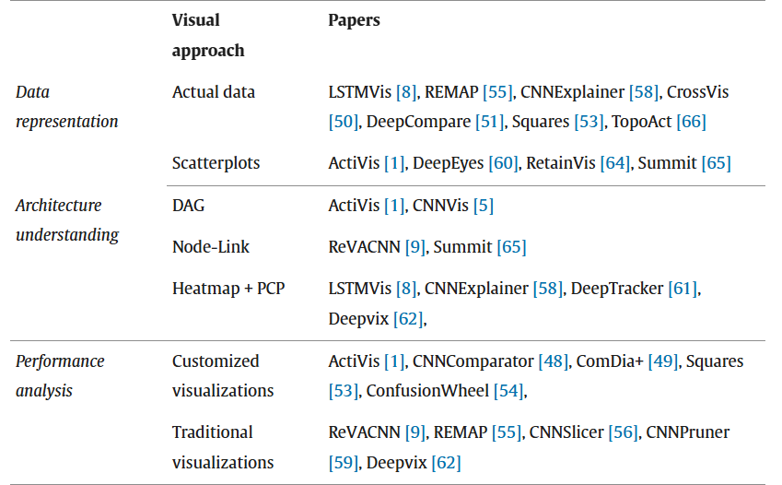

Visual-Based (vXAI)

Very limited work still exists in this field. To make NN more transparent, we adopt XAI techniques. Model usage is grouped for XAI methods; we group by subsection based on feature-based, rule-based, propagation based, and other methods.
Feature based methods
Feature-based XAI shows feature importance in contributing to predictions.
LIME is the most popular model agnostic method (can be used with any model). The XAI method is often adopted in VXAI. LIME works by creating training samples by perturbing neighbors around the user's selected instance, then using a surrogate model to explain the instance locally. The surrogate models are much simpler than linear models that approximate the black-box models. The obtain feature importance from this linear surrogate model. VA platforms such as ExplainExplore, SUBPLEX and DeepVID, have modified and integrated LIME to explain NN locally.

ExplainExplore modifies LIME to increase explainability by using LIme’s Linear surrogate model and a shallow tree-based surrogate model. It provides explanation locally for a selected instance by displaying generated samples interactively and allowing direct manipulation.
DeepVID improves the training sample generation process through deep generative networks. It allows users to select sample regions around one or more selected instances and provides local explanations.

SUNPLEX displays the average feature contribution to provide explanation for selected subgroups. This is done by modifying LIME method.

SHAP is another popular feature based XAI method, In Li et Al’s work, they adopt SHAP in their VA system for the interpretation of clinical data. Local explanations of both individual and clustered instances were presented interactively. The tool created also allows comparison of multiple models by displaying the similarities of ML models based on their local feature importance. This was done by using a scatterplot in T-SNE.

It’s interesting to note that exploration at the feature-based method is limited to only local instance in this survey paper

Rule-based methods
This method provides logical statements, i.e., IF THEN, and ELSE to explain predictions.
RuleMatrix displays graphical representation of rule-lists obtained by bayesian rule lists. RuleMatrix visualizes IF-THEN rules in the form of a matrix, for groups that satisfy the related rules.
XDNN provides prototype–based IF-then rules to explain NN by displaying similarities between validation and selected image.
Model Diagnostics adopts rule extraction methods to present local and group level explanations for binary classifiers.
ModelSpex employs a rule extraction technique to provide rule-based explanations for decisions.
Model diagnostics and Modelspex do not visualize IF-Then rules; they focus on the explanations of logical representations.
It’s interesting to note that exploration at the Rule based method is limited to only local instance in this survey paper
Propagation-based methods
XAI methods such as LRP, CAM, Grad-CAM, back-propagate predictions to obtain feature relevance in explaining ML models at both global and local levels.
Lauritsen et al. Used LRP to find feature importance in explaining predictions at both instance level and population-based levels for acute clinical illness records. Saliency maps were used to highlight the contributions of features for each sample through propagation.
Li et al used saliency maps to explain contributions and negations of words to the predictions obtained by LSTMs. CAM and Grad-CAM methods were proposed to improve saliency.
Kim et al. Utilized CAM method to obtain saliency values for text classification. Saliency maps are used to explain CNN in grayscale.
The majority of VA research is integrated into specific types of XAI methods. Since it is difficult to model and explain them individually, iNNvestigate a python package has been developed to compare NN and XAI methods. It compares how NN models will behave in certain instances through the visualization of feature contribution using the selected XAI method.
INNvestigate supports propagation based XAI methods such as Saliency maps, integrated Gradient, and LRP
ExplAIner and MELODY support propagation and feature based XAI methods such as LIME, LRP, SHAP, Saliency Maps, DeepLIFT to provide vXAI explanations
These comprehensive XAI and Model tools provide both local and global explanations.
Other Methods
Case-based Reasoning is another type of XAI that helps to explain using decision based on similarities of previous cases, This XAI is commonly used in medicine domains. Lamy et al. Used a case-based reasoning approach to explain clinical datasets as rainbow boxes. These rainbow boxes explain the AI model via weight and case similarities.
iForest uses the MDI method, which is a model specific method for random forest, used to present feature-based explanation. It explains the decision paths based on feature ranges. IForest supports Case-based reasoning by adopting similarity measures of both data similarity and decision path.

Exploring the visual approaches used in data representation of local and global explanations adopted by vXAI research
This section focuses on the visual representation of data to be more accessible for users.
Rule Matrix displays data in a table form, so specific instances or subgroups can be focused on by filtering
iForest also adopts a table form to represent data; it allows for browsing and selecting instances or subgroups for exploration.
Image dataset’s important features are often explained with images; these can be found in models such as explAIner, Meske and Bunde, and DeepVID.
Kim et al and Li et al. Presented text data by displaying each instance as text box
Scatter plots using dimensional reduction techniques are being used to understand a lot of high dimensional datasets; these help to reduce visual clutter.
Botari et al, baptista et al, Lauristen et al. Presented tabular data enhanced by DR techniques in scatterplot
DeepVID also represents data supported by DR techniques through color-coded classes obtained by t-SNE in scatterplots. This allows users to select individual instances or subgroups to understand the predictions.
SUBPLEX uses scatterplots with a DR technique called Local Affine Multidimensional Projection (LAMP) to show subgroups in the data. LAMP maps the attributions in a 2D plane by presenting the subgroups produced by the LIME method.
Sankey diagrams show how data and instances flow through overall data feature distribution. RuleMatrix uses a color-coded Sankey diagram to display data flow through rule lists for tabular data. Sankey diagram allows users to follow the data satisfying the rule by observing the width of the Sankey diagram flow. MELODY uses a Sankey diagram to visualize the data flow from each class to different clusters for various domains.

The Paper then goes on to highlight explanations that are done on the Local level and Global level. The tools that explain at these levels were also highlighted. The table below lists and categorizes them:

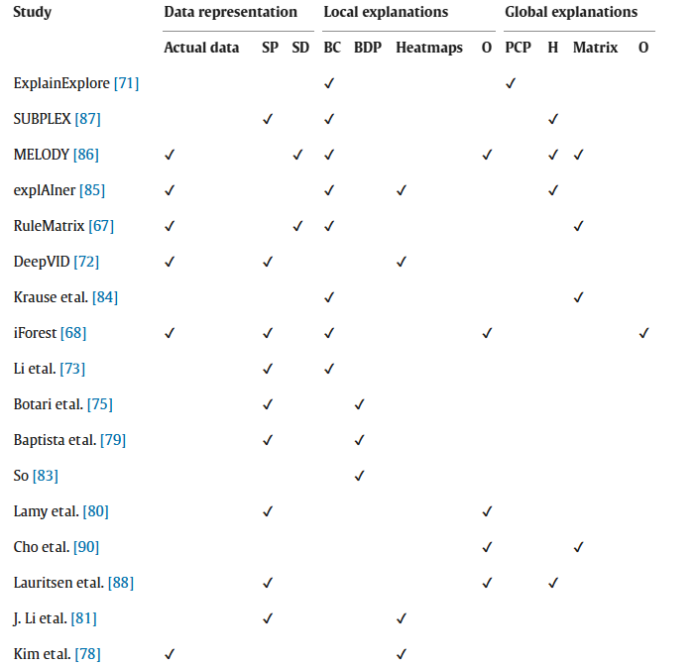
Discussions and opportunities for future work
Scalability is one pf the challenges faced with XAI. Having visually scalable data representations is quite challenging currently as most data used in the real world are high dimensional datasets and are likely to cause clutter if visualized. A solution to this is the use of color-coded scatterplot enhanced by dimensionality reduction techniques to provide scalable data visualization. However, high dimensionality will still cause overlapping data points and scalability issues because the VA system will not visualize them. Clustering is another technique used to handle high-dimensional datasets.

Feature understanding: feature selection is very important for the accuracy and performance of a NN model. Good feature selection reduces the noise and improves the accuracy of the Model. Several methods Most recent studies support the integration of feature selection in VA tools to improve the model's performance. Current visualization studies visualize feature weight over layers of NNs and highlight feature relevance for the final decision, these tools how ever do not allow for much interaction and manipulation of feature space to understand the model behavior and predictions.
Model Diagnostics removes features one by one until there is a change in the prediction result to understand the effect on the features on the prediction. There is still room for development in terms of feature effect understanding, future research can be directed towards understanding how feature selection and extraction can make a difference to result/weight/activations on neurons, with human inclusive interaction.
Architecture understanding: In terms of architecture, tools have been created to visualize the network of NN models using heatmaps. Tools such as ActiVis and CNNVis use acyclic graphs to interpret deep learning models. CNNExplainer uses heatmaps to represent nodes and shows internal operations for selected prediction instances. The limitation when it comes to architectural understanding is the inability to get Realtime visualization of the model running. The obstacles preventing this are limitations such as time, computational resources, and scalability.
What Visualization method will be used: There is a plethora of visualization techniques suitable for both the local and global explanations, and as XAI is still a relatively new field, more are still going to be used. It’s important to use a visualization suitable for our needs. There will be challenges with selecting what visuals to use as a model can be represented in different ways. It’s important to pick a model that can be easily understood.

Usable XAI: 10 strategies Towards Exploiting Explainability in the LLM Era PP 1:25 ( file:///C:/Users/c7637408/Downloads/Usable%20XAI-%2010%20Strategies%20Towards%20Exploiting%20Explainability%20in%20the%20LLM%20Era.pdf)
As AI has continued to advance, there is more demand for the models to be understood. While convolution networks and recurrent neural networks' opacity have not been fully solved, a more capable system (LLMS) has been developed which appears to be causing more complexity, raising new questions about our understanding of AI. Being that these systems can reason for themselves and even provide answers to questions, we have more of a need to understand its processes.

There are two criterions used in defining usable AI, these criterions are:
- Leveraging XAI to improve LLMs and AI systems, here we hope to pinpoint model issues and improve overall performance
- Enhancing the usability of XAI through LLM, this pertains to the user friendliness of AI. Due to human-like communication of LLMs, it can enhance system explainability in terms of user-friendliness. Also, LLMs common sense knowledge plays the role of humans, thus reducing human involvement in AI workflows.

Contribution of this paper:
Leveraging XAI to improve LLMs and AI Systems: I this paper, interpretation is leveraged to improve the XAI system. We follow the LLM development pipeline in reverse order; post-hoc analysis, prompt improvement, and data enhancement.

Enhancing XAI usability through LLMs: In this part, Strategies for leveraging the advanced capabilities of LLMs to address the challenges in traditional XAI domains. By using LLMs to examine the user friendliness of explanations through generative capabilities and automating the workflow the workflow of interpretable AI using LLM and thirdly simulating the effectiveness of the XAI system by using LLMs to emulate human cognition processes.

The attribution methods as post-hoc are used to detect defects in models with attribution scores. This paper goes on to discuss attribution methods that are suitable for LLMs and can be used to design novel post-hoc explanations for LLMs.
Y= f(x)
f is the language model
N-words input prompt x
Y is the prediction of the model

For the attribution method:
a=g(x,y,f)
G assesses the influence of input words in x
A store the importance score of words
Y is the specific class label in text classification or varying length of generated text in text generation

Common attribution methods for deep learning are gradient-based methods, perturbation-based methods, surrogate methods, and decomposition methods.
- Perturbation-based explanation perturbs models and then monitors changes in models' prediction confidence
A_{n} = p(y|x) - p(y|x/n)
Where x/n refers to the input sequence with the nth feature being perturbed or deleted
The limitation of this approach is in its assumption of independent features and its computational requirement
- Gradient-based explanation is a computationally efficient method to estimate models' sensitivity to its features.
where x_{n} refers to the embedding of word x_{n}
This approach requires singular inference and backward propagation to estimate a word’s sensitivity. It is computationally expensive.
- Surrogate-based explanation constructs a simpler model of the original model. for instance target model f will have a simpler surrogate model g trained on
The goal is to explain a single prediction f(x)=y^n made by a complex "black box" model like an LLM. To do this, we create a simple, understandable model g (like a linear regression or a small decision tree) that mimics the complex model's behavior in the immediate vicinity of instance x.
We do this by:
- Perturbing x to create many new, slightly different data points x~k .
- Querying the black-box model f to get the predictions y~ k =f(x~k ) for these new points.
- Training the simple model g on this new, synthetic dataset D={(x~k ,y~ k )}k=1K .
The key is that not all perturbed points are treated equally. Points very similar to the original x are considered more important for the explanation than points that are very different. The surrogate models can range from basic models to more complex models. The limitations of the method is its continuous interaction with the target model causing it to require a lot of computational power and due to the complexity of LLM models, they are quite difficult to replicate as simpler models.
-Decomposition-based explanation: this type of explanation linearly additive relevance scores to inputs, effectively breaking down the model’s prediction. The challenge for this is that there is not a model's agnostic decomposition strategy, and each model needs its own tailored method.
Attribution method for text generation
LLM generation can be defined as attributing the overall confidence P(y|x) to the input x, where y denotes the generated response y = [y1, ......., ym] with M number of words. Wu et al. proposes a gradient-based method for input-output attribution. Specifically, the importance score 𝑎𝑛,𝑚 defined between input token 𝑥𝑛 to output token 𝑦ˆ𝑚 can be estimated as:
where 𝑦ˆ1:(𝑚−1) denotes the first𝑚 −1 tokens of response,
𝑥/𝑛 means removing the 𝑛-th input token from 𝑥,
E[𝑥𝑛] is the embedding of token 𝑥𝑛.
The total contribution of each input word 𝑥𝑛 can be estimated by averaging the attributions 𝑎𝑛,𝑚 for 𝑚 = 1, ..., M
TIME COMPLEXITY: This is an important consideration when using the attribution method for large language generation models like LLM, due to the computational requirements. This particularly applies to perturbation methods and gradient-based methods. While surrogate based methods and decomposition methods are limited because they are model specific and must be tailored for the model being studied.
Attribution is also used to leverage the generative capabilities of LLMs to provide citations to one or more text passages that support the output they generate. The cited contents can originate either from external sources or from the LLMs’ own memory. RECITE was introduced by Sun et al, which first retrieves one or more relevant passages from the LLMs’ memory via sampling and then generates the final response based on these passages

Usability of Attribution methods for LLMs
LLMs benefit from attribution in two scenarios, Model Diagnosis and Model enhancement
Model diagnosis: By comparing the output of LLM’s with attribution results, we are able to detect unsupported information. Gao et al. proposes a framework called RARR, which leverages attribution to identify unsupported or misleading content generated by LLMs. In particular, the attribution step is automated by using a query generator to produce comprehensive questions about different aspects of the text that need verification. In addition, Agrawal et al. propose "consistency checks", which asks the LLM to perform attribution multiple times for the same output. Inconsistencies in the attribution results show issues with the LLMs output.
Model Enhancement: Attribution can provide prompts to improve models' performance, Sun et al proposes “recitation” as a new two-step approach where LLM recalls a relevant factual knowledge a from its own memory before generating the result, like how a student recalls a study before answering a question. 𝑦ˆ = 𝑓 (𝑥, 𝑎) instead of the standard 𝑓 (𝑥), a is the models recollection.
Krishna et al proposed a framework called AMPLIFY, which uses attribution to improve LLM performance by crafting effective prompts. It does this by selecting sample validation sets that were misclassified by the LLM and uses another model to compute their attribution scores.

Challenges
The two major challenges facing attribution for the explanation of LLMs are efficiency and faithfulness. The existing frameworks pertaining to attribution available for understanding LLM are used primarily for simpler models such as regression or classification and would be more computationally expensive if applied to LLMs. There is a need for a new framework that goes beyond the capabilities of the current framework tailored for LLMs.

LLM DIAGNOSIS AND ENHANCEMENT VIS INTERPRETING MODEL INTERNALS
In this section, we discuss XAI methods that are used to interpret LLM internals. This research focuses on interpreting model components and latent representations

LLMs adopt transformers as their basic architecture; transformers comprise two types of major components: self-attention Mechanism (ATT) and Feed-forward Network (FFN). The individual components as well as their interaction were observed to gain insight into the functioning of LLM systems

Linear Relation between components
A decoder only LLM f is considered with L internal layers, each layer is either ATT or FNN layer, denoted by f¹ . There is an input embedding matrix W_{e} that encodes each word of input text x into D-dimensional vector, x ⁰ = W_{e} [𝑥] ∈ R ^{|𝑥 |×D} . The internal representation at each layer is computed by x ^{𝑙} = 𝑓 ^{𝑙} (x ^{𝑙−1} ) + x ^{𝑙−1} . Then there is an embedding matrix W_{u} that decodes the hidden representation for the next word prediction i.e 𝑓 (𝑥) = x ^{𝐿} · W_{u} the final prediction gives us

𝑓 (𝑥) = x⁰ W_{u} + $\sum_{l=1}^{L}{f^{l}\left(x^{i-1}\right)W_{u}}$ (Layer update)
x⁰ W_{u} = Residual Stream

This equation explains the function of LLMs,
- Model prediction is a sum of layer outputs, the final prediction is a combination of the initial input embedding and the contribution from each layer
- It is through extraction from the residual input at each layer and the injection of processed output back to said residual input that multiple areas work collaboratively carry out specific tasks.
Importance analysis on single component: here we would like to know the specific impact a single layer f^{l} has in predicting a certain word w under the context of x by computing f^{l}(x^{l-1})W_{u} [:,w], a greater value indicates greater impact. Researchers proposed that to better understand the contextual impact of the layers, an intervention on layer output will be required. diff(hWu[:,w],$ℏ$Wu[:,w]). Diff measures the difference between the two points h = 𝑓 ^{𝑙} (x ^{𝑙−1} ) and $ℏ$ is an intervention of h

$ℏ$Could be a constant vector, noise vector, and a hidden representation of other contexts.

Researchers have also extended this framework to analyze the global impact of a single layer f^{l} in predicting the word w by using w_{o}^{l}.w_{u}[: w], where w_{o}^{l} is the output weight matrix of layer f^{l} and has mapped its output back to the residual stream.

Circuit Analysis on Multiple Components: It is important to understand how different layers work collaboratively; this is called circuit analysis. The specific goal of circuit analysis is to identify the functions done at different layers of the model, for instance what subset of the layer is responsible for tasks such as indirect objects classification, and number comparison. By using the residual stream to communicate across layers, researchers proposed using acyclic maps to represent the forward pass of an LLM. Where each node is a particular layer, the edge is a representation flow from one layer to another via the residual stream. For circuit analysis under the proposed acyclic graph, circuits are represented with sub graphs with distinct functions. Identifying specific circuit requires:
- Selecting the task of interest and collecting the dataset
- Building the model’s graph
- Measuring the importance of sub-graphs with interventions
This process can be quite tedious as it requires a large amount of forward passes for intervention. To optimize this process, scientists propose the use of gradient-based methods to approximate the intervention results with one backward pass for each sample.

Usability of Component Analysis: Component analysis allows researchers to isolate the entire LLM into different parts for specific tasks. This overall benefit of this is researchers are now able to optimize a model, Modifying or removing certain parts that are essential or repetitive in the model. The two common applications of component analysis are Knowledge editing and Model pruning

Knowledge Editing: Component analysis can be used to find the exact storage position of a relevant knowledge and then update it accordingly to prevent extensive effect on another dependent knowledge. For instance, outdated knowledge t =(s,r,o) can be updated to a new one t^{l} = (s,r,o^{l}).

Model pruning: Component analysis allows researchers to locate the specific component of a model that performs a specific task. Therefore, irrelevant or redundant components can be removed to improve the model. Dropping redundant parameters has been shown to improve inference time without sacrificing performance.

Explanation of Latent Representations
Researchers have studied latent representation of LLMs to understand model behavior; however, due to the polysemantic nature of the representations, they are not easily interpretable. There are several things to consider when trying to understand latent representations, for easy understanding, we categorize the various challenges to tackle according to whether they require additional training or not.
Non-Training based Methods
Both the input and output layer of transformer based LLM f are easily understood as they are represented in human readable text. Since all layers share the same residual stream and it flows seamlessly between layers, non-training methods capitalize on this by transferring the hidden representation x¹ to either the first or the last layer to facilitate interpretation.
- Projecting x^{l} to output embeddings. With X¹ at layer l, Logit lens understands its semantics by projecting it to the output word embedding matrix W_{u} . Specifically, X¹ is interpreted by collecting the K words whose output could maximally activate X¹
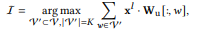
V is a pre-defined vocabulary set
- For every word w in the vocabulary V, compute the dot product xₗ · Wᵤ [:, w]. A higher dot product means a stronger match.
- Find the top K words (the subset V') that have the highest dot products with xₗ.
- This list I of top-K words is the interpretation of the hidden state xₗ. It shows what concepts or tokens the model is "thinking about" at that specific layer.

- xₗ: This is the model's internal, hidden state at layer l. It's a high-dimensional vector that represents the model's "understanding" of the input up to that point.
- Output Embedding Matrix Wᵤ: This is a lookup table where each column is the embedding vector for a specific word in the model's vocabulary. The final layer of an LLM uses this matrix to convert its internal state into a set of scores (logits) for every possible next word.
- Projecting: This is a mathematical operation (a dot product) that measures the similarity between the vector xₗ and every word embedding in Wᵤ.
- Analogy: Imagine xₗ is a thought in your mind, and Wᵤ is a dictionary of all possible words. "Projecting" means looking up every word in the dictionary and seeing how well it matches or expresses your current thoughts.
The Logit Lens is a simple but powerful trick to "peek" into the middle of this process. It takes the model's internal state at any layer and directly asks: "If the model stopped thinking right here, what would it predict next?"
- Feeding xl as input Embeddings: Instead of projecting the hidden layer xl to the output layer, self-IE proposes feeding it as an input word embedding in another round of model inference, where LLM is prompted to explain it.
Supervised Training based Methods
Supervised training-based interpretation methods break the polysemantic nature of LLM latent space by leveraging some annotated datasets. It focuses on two research questions
- Whether the LLM latent space encodes a certain concept
- Whether this concept impacts the LLMs predictions
Identifying Existence of certain Concepts: Probing is the most traditional technique in analyzing the knowledge encoded within hidden representation of LLM. The probing technique requires an annotated dataset to train a probe p with parameter $θ$to predict the occurrence of interested knowledge
P : x $→$[0,1]
Where x is the latent space
The dataset consists of positive samples with label “1” that are of interest and negative samples to be excluded. If a probe p achieves a significantly high accuracy on a certain dataset, we conclude that latent representation encodes that concept. The improvements in the probing technique focus on designing baselines to confirm high accuracy is achieved by probe p is led by the knowledge provided by the latent space x.
Measuring Importance of Certain Concepts: TCAV is used to quantify how a specific concept impacts the model’s prediction. We first train a linear probe p with parameter $θ∈R$^{D} to distinguish latent representations containing concept c or not, where $θ$is the concept activation vector (CAV). The sensitivity of models output to perturbation along with the concept direction is measured with TCAV. If models prediction changes substantially when representation is shifted along the learned concept direction, we can conclude that the concept has a high importance for the model’s decision.
Perturbation is realized mathematically by computing the gradient of f(x) with respect to x^{l}
$∆=∇x^{l }$^{F(x).}$θ$
^{The larger} $∆$indicates that small shifts in the latent space along $θ$lead to substantial changes in f(x). Underscoring the concept’s influence
Unsupervised Training based Methods
Breaking down the polysemantic problem of interpretation can be done as a unsupervised learning problem on the basis of vectors of the LLM latent space, where each basis vector refers to a clear and concise semantic concept.
given a N hidden representations
$$Χ∈R^{NXD}$$
- X ∈ ℝ^(N×D): Your data matrix with N instances and D features
- Goal: Factorize X into two matrices:
  - A ∈ ℝ^(N×C): Coefficient matrix (how much each instance uses each concept)
  - C ∈ ℝ^(C×D): Concept matrix (the actual concept vectors)

The Optimization Problem
You're solving:
arg min A,C ∥X − AC∥²
This is essentially finding the best low-rank approximation: X ≈ AC

Interpretation
- C (C×D): Contains the learned concept vectors
  - Each row is a "concept" in the original feature space
  - These should be interpretable basis vectors
- A (N×C): Contains the concept activations
  - Each row shows how much each instance uses each concept
  - Each column shows how a concept appears across instances

The Key: "Monosemantic Concepts"
The mention of "additional conditions to ensure monosemantic concepts" is crucial. This likely means:
- Sparsity constraints - Concepts should be simple and focused
- Non-negativity constraints - For interpretability
- Orthogonality - Concepts should be distinct
- Simplicity priors - Preventing complex, entangled concepts

The Core Idea: Understanding a Complex Machine
Imagine a giant, complex machine (like a Large Language Model - LLM) that takes in text and outputs text. We want to understand how it works inside. Our theory is that the machine thinks by combining simple, fundamental "ideas" or concepts.
Our goal is to find these "concepts." The method described is like trying to reverse-engineer the machine's internal thought process by looking at its internal data.

Part 1: Two Strategies to Find the "Concepts"
The text describes two main strategies to find these concepts, which we'll call Matrix C (the list of concepts).

Strategy 1: The "Neat and Tidy" Method (Orthogonal Assumption)
- The Idea: Imagine your basic concepts are like the primary colors (Red, Green, Blue). They are perfectly distinct and don't overlap. You can't create Red by mixing Green and Blue. In math, we call this orthogonal.
- The Method: Use a classic mathematical technique (Singular Value Decomposition - SVD) to find concepts that are perfectly orthogonal (CC⊤ = I).
- The Problem: For a giant AI model, this is like trying to sort a billion LEGO pieces into perfectly separate, pure-color piles. It's computationally expensive and doesn't scale well. It's too rigid for the messy, interconnected nature of language.

Strategy 2: The "Good Enough" Method (Sparse Assumption - Sparse Autoencoder)
A = Top-K (X · C^{T}),
- The Idea: Let's relax the rules. Instead of demanding concepts be perfectly distinct, let's demand that they be used simply. For any given input, the AI should only use a few concepts at a time.
  - Analogy: To describe "apple," the AI might activate the concepts [FRUIT], [RED], and [SWEET], but not activate [OCEAN], [CAR], or [SADNESS]. The activation pattern is sparse (mostly zeros).
- The Method: This uses a small neural network called a Sparse Autoencoder (SAE). It learns to compress and then reconstruct the AI's internal data.
  - Top-K Activation is the key: It looks at all the potential concepts and says, "Only the top K most relevant concepts for this input can be active; all others must be zero."
- The Advantage: This method is more flexible and has been successfully used to peek inside billion-parameter models like GPT-4. It's current state-of-the-art.

Part 2: The Challenge of Naming the Concepts
Once you have these concept vectors (rows in Matrix C), how do you understand what they mean? The text describes two approaches.

The Old Way: Explain by Input (The "What Goes In" Method)
I𝑐 = arg${}_{MAX_{X^{'}⊂X,\left|X^{'}\right|=M}}^{}{}$ $\sum_{x∈X^{'}}{}$ 𝑓 (𝑥)C[𝑐].
- The Idea: To understand concept #42, find the real input texts that make the AI activate this concept the most.
  - Formula: I𝑐 = arg max ... simply means "Find the set of M input texts that cause the highest activation for concept c."
- The Problem: Recent research found a flaw. Just because a concept activates for a certain input doesn't mean it causes the AI's output. It might be a side effect or correlate with the true cause.
  - Analogy: You see that the "SUMMER" concept activates strongly for the word "ice cream." But does the "SUMMER" concept directly cause the AI to talk about ice cream? Or is it just correlated with other concepts like "HEAT" or "DESIRE" that are the real drivers?

The New Way: Explain by Output (The "What Comes Out" Method)
- The Idea: Don't just look at what inputs activate a concept. Instead, force the concept to be active and see how it changes the AI's output. This builds a direct causal link between the concept and the text the AI generates.
- This is considered a more reliable and advanced way to interpret what these learned concepts do.

State of the Art of Visual Analytics for explainable Deep Learning
https://onlinelibrary.wiley.com/doi/full/10.1111/cgf.14733

Self-explainable DNNs include components in the model architecture to ease the explanation of the results. This is a novel category for DNNs, and is used in attentive models, models based on prototypes (Neural language models).
Number visualization: Bar chart, Pie charts, Line charts and Area charts, and heatmaps
Multidimensional Data Visualization techniques: Scatterplot. For high-dimensional data, dimensionality reduction techniques (e.g. PCA, MDS, t-SNE, ISOMAP, and UMAP) are used with scatterplots. Parallel coordinate plots (PCPs) show multidimensional data as polylines that cross vertical parallel axes. Clustering or sampling or axes sorting have been proposed to improve parallel co-ordinate plot visual sorting. RADVIZ and star coordinates are two popular methods that present high dimensional data as 2D points on a radial layout while keeping the same relationship with their original dimensions.
Hierarchical data Visualizations: Tree maps, using hierarchical representation such as nested rectangles.
Network visualization: Adjacency matrix or node-link diagrams.
^{Important concepts}
Gradients: their magnitude describes how a function f (.,.). Changes the values of a variable. It is often used to compute the contribution of each feature to the prediction by back propagating the gradient information from output to input.
Perturbations: the idea of perturbation-based method is to modify the current input to probe the model’s behavior to test scenarios and extract insights.
Activations: They are the core element of DNNs, and several methods propose to analyze them to extract insights about their behavior
Search algorithm: Explanation methods can use search algorithms to extract samples from data and use them as explanations
Attention weights: they are one of the latest tools used for explainability, and they can be combined with the structure of the models, often done in self-explainable DNNs.

Multiplex network-based representation of vision transformers for explainability(https://leedsbeckett-my.sharepoint.com/personal/e_olanrewaju4233_student_leedsbeckett_ac_uk/Documents/Attachments/s00521-025-11591-x.pdf)
This paper talks about explaining vision transformers using a novel approach called MUTEX. MUTEX combines multiplex network-based representations of attention matrices and mask perturbation approaches to provide insight into the inference process of ViTs. By mapping the attention layers of a ViT into a multiplex network, MUTEX can analyze the relationships between different parts of the input image and identify the parts of the image that influence the output inference.
Attribution-based approaches modify some parts of the input data to describe the model's inference process, but struggle with non-linear relationships.
Attention-based approaches use attention mechanisms of the transformer to understand model inference but struggle with reliability as attention weight and model output have a weak correlation
Interpretability-aware approaches modify the original architecture to create new models, that are easy to explain and understand; their way of operating makes them unable to work with pre-trained ViTs and suitable only for specific settings.
Masked-based approaches selectively omit part of input data and observe the resulting effects on model output, this method could be computationally expensive due to the number of masks required
MUTEX combines key ideas from different approaches, Mutex addresses the non-linearity in patch relationship by constructing a multiplex network on top of the attention matrices, capturing patch interactions across different layers and modelling the information flow within the ViT. MUTEX solves the problem of attention-based approaches by creating masks which connect the attention weight to the output of the model. Based on the output inference, MUTEX identifies salient areas and constructs the final heatmap.
MUTEX provides visual explainability for ViT in two ways. First, it maps the attention layers of a ViT onto the multiplex network-based representation that highlights the relationships between parts of the input image. In the second task, it uses the generated multiplex network to identify the most important patches based on centrality measures and aggregation functions and then constructs a set of masks corresponding to specific parts of the image. It then merges the masks using the Models class confidence score and coverage bias formula. The construction of multiplex-based networks is done several times within the heatmap generated.
The first task T of the VIT receives image I to explain and an aggregation function $ϕ$ belonging to a set $Φ$of aggregation functions. It extracts the attention value of the image I, it then aggregates the attention heads to corresponding extracted attention values and makes a multiplex network $M_{T,I,ϕ}$.
The second task receives image I to explain, a set $Φ$aggregation functions for multiplex network construction, a set $Γ$of aggregation functions for node centrality values, and a set of centrality measures $Ξ$. for each aggregation function $ϕϵΦ$, it activates task 1 first to activate the multiplex network, Task 2 activates task 1, which computes attention values and aggregates attention heads using $ϕ$and creates a multiplex network $M_{T,I,ϕ}$. Then for each $γϵΓ$ and for each $ξϵΞ$task 2 receives a matrix $M_{T,I,∅}$ computed by task 1, computes a masking matrix $Χ_{γ}$, computes a confidence score $σ$associated with $Χ_{γ}$, computes the weighted masking matrix $Σ_{γ}$, aggregates the weighted masking matrices $Σ_{γ}$ to obtain, aggregates the masking matrix $Χ_{γ}$ to obtain $Χ_{}$ and then compute the final heatmap $H$.

AttentionViz: A Global View of Transformer Attention
(https://ieeexplore.ieee.org/stamp/stamp.jsp?tp=&arnumber=10297591)
The goal of this study is to understand the self-attention mechanism of transformers; this is the most revolutionary discovery in transformers as it allows transformers to learn and use the rich set of relationships between input elements. Although self-attention has been studied, previous techniques generally visualize information related to just a single input sequence at a time. Previous research produces bipartite graphs or heatmaps representations of attention weights for one given input sequence. The primary technique of this research is visualizing a joint embedding of the query and key vectors used by transformers, which then creates a visual signature for an individual attention head. AttentionVIZ is an interactive visualization tool that allows users to explore multiple levels of details, with the option to view attention heads globally or zoom in on details in a single attention head. An effective method to visualize multiple inputs is to visualize a collection of embedded vectors from multiple input sequences. Gaps this research fills, visualizing query and key embeddings in transformer models; artefacts of self-attention queries and keys are underexplored. Secondly, other research compares multiple embeddings; they do not only compare embeddings at different transformer heads and layers, but The Global matrix was also designed to do this. This paper applies bipartite graph representations which were proven to be successful with NLP-based transformers. transformer attention layers consist of multiple attention heads, each of which can represent a different pattern of attention and information flow. Each attention transformer head turns input embedding into query vectors and key vectors by applying matrices $W_{Q} and W_{K}$ respectively. These matrices then project the vector embedding to a lower dimensional space, getting only specific information from the higher-dimensional vector embedding. By inspecting the key and query vectors, the author hopes to learn what information is selected by the matrices. A key observation is that the relative positions of query and key vectors can offer insight of how attention will be distributed, since attention coefficients depend on the dot product between queries and keys. Closer distance directly shows higher attention coefficients. In practice, query and key vary in norm, so the relationship between dot product and distance is not precise. We can, however, arrange for the relationship to be close. An interesting insight from vision transformers is how attention heads group images by hue and brightness.
Gaps in literature this research fills
- This research fills three gaps in literature, the first is visualizing embedding vectors. There is no known systematic attempt to visualize query and key embeddings in transformer models, and the self-attention properties of queries and keys are under explored.
- There is also no visualization technique proposed for multiple embeddings, Thus, we design a global matrix view to visualize query-key embeddings at scale.
- Finally, bipartite graph representations have proven helpful in analyzing NLP-based transformers, but we have not seen them apply to vision tasks.
An example of the attention head in language transformer, we obtain the key and query vector representation of each token in each sentence, then use dimensionality reduction techniques such as t-SNE, UMAP or PCA to project the high-dimensional vector into low-dimensional space. The output of the reduction is in 2D/3D scatterplot format; each point represents a single query or key token. The same process is applicable to joint embeddings for VIT’s attention head, where each token is an image patch, for instance we visualize queries as green and keys as pink. This allows users to explore interactions between queries and keys; these often can visualize the underlying self-attention patterns. It's important to note that each dimensionality reduction technique will produce different patterns. Vector normalization is applied prior to dimensionality reduction; this is to tune the ‘free parameters’ and create a closer relationship between embedding distance and attention weights and is done by applying the SoftMax function. In transformers such as GPT-2, we noticed that the average query norm was very different from the average key norm, making it hard to interpret, queries were tiny clusters and keys were loose clouds. Scale query by C! = 0 and key by C ^ (-1) to get a closer norm
Ideally if the query-key pair has a large, positive dot product (meaning high attention value) they should be placed closer together in the embedding space, meaning distance is inversely correlated to our attention value.
Attentionviz offers various color customizations for token types (key or query). For vision transformers, users can color by image patch row or column to visualize positional patterns. For language models, color options are normalized and discrete. This research framework provides three interactive views, Matrix view, single view, and sentence/Image view.
Matrix view uses small multiples to visualize the attention heads in the transformer at once. Each row corresponds to a model layer. This provides a Global perspective that users can easily scan for patterns across different transformer layers and heads. In matrix view joint query-key embeddings created with dimensionality reduction techniques can be viewed. This view allows for customization in terms of color and model change.
Single view, any plot in the matrix view can be clicked on to zoom into a single view, which allows the exploration of a single attention head in closer detail. It allows for the same customizations available in Matrix view. Users also have the option to project attention lines onto the scatterplots, which connect query and key tokens, and show only the top two attention weights for readability.
Sentence/image view allows for the exploration of fine-grained attention patterns within a single sentence or image.
Sentence view: When using BERT or GPT-2 users can click on a point in single view to open sentence view in the left sidebar, which displays BertViz-inspired visualization of sentence-level attention with the clicked token highlighted, bipartite approach offers the best readability. The opacity of connecting query tokens to key tokens shows the strength of attention. Hovering over a token highlights a token-specific attention line. To reduce noise from classification tokens and separators, attention lines can be hidden.
Image view: For image-based input in ViT, when an image patch is clicked on, the clicked token is highlighted with colored border, users also see an image overlaid with an attention heatmap, transparency indicates the attention weight between the clicked image patch and other regions of the image. The overall attention pattern within an image can also be explored by showing arrowed lines between different image patches. There are two options available for visualizing attention arrows: the first option overlays arrows on the top of the original image patches, with the strongest attention connection between a starting image patch and destination patch. The second option shows all strong attention connections besides the original image, offering a more comprehensive view of attention. It only focuses on self-attention and is computationally expensive.
System implementation and Methods
- Hugging face Transformers library and pytorch, Pretrained implementations of BERT, GPT-2(small), and ViT-16/32 with model weights from google and OpenAI.
- For each NLP dataset, randomly sample 200 sentences (10k tokens), 10 images per head (1000 tokens) for ViT-32 and 4 images per head (1576 tokens) for ViT-16
- After extracting query and key vector embeddings for each attention head, we generate the corresponding 2D/3D t-SNE, UMAP, and PCA coordinates
- To produce semantic labels (e.g., “dog” or “background”) for image patches in ViT, we use the DeepLabv3 segmentation model
- AttentionViz prototype consists of a Python/Flask backend that communicates with a frontend written in Vue and Typescript.
- use Deck.gl to visualize the resultant query-key joint embeddings.

VisBERT: Hidden-State Visualizations for transformers
( https://dl.acm.org/doi/abs/10.1145/3366424.3383542?casa_token=jxT0l_bdld8AAAAA:vuLIewTf0OJ53dGJsA7uUTGTGWIqFCpBdyNSNJYOPvVW7GwqDRTefwlFaFZbastavYJA6Gwprsw0 )
From prior research, it is understood that attention cannot be solely relied upon for the purpose of explainability, this research aims to investigate a complimentary approach that might aid this effect, instead of attention values, the visualization of hidden state between BERT layer and with token representations as they are transformed through the network. This experiment was performed on publicly available QA datasets SQuAD, HotpotQA and bAbI QA to show the tools applicability on three diverse QA tasks including multi-hop reasoning cases. The principle of VisBERT can easily be extended to other up or downstream NLP tasks. The method of explainability is achieved by following the transformation of tokens throughout the network. Each layer of BERT outputs a different token distribution. To understand the semantic relationship between token vectors, we consider the distance between token vectors.
For the given QA sample, we collect hidden states from each layer while removing padding; visualization is done on a token-to-token basis. We use the hidden state after each encoder block; these states contain vectors with a dimensionality of 768 (BERT-base) or 1024 (BERT-large). We apply dimensionality reduction to the vectors obtained from the hidden state, since high dimensional data is not directly interpretable. Dimensionality reduction maps the high dimensional data into low dimensional space form a 2Dimensional representation of data. The most suitable method for dimensionality reduction in this instance is PCA, and it reveals clusters that correspond to those observed by k-means clustering. For the QA tasks, we use BERT-base model (12 layers) for SQuAD and babi and BERT-large (24 layers) for HotpotQA, because the base model does not perform well on such difficult tasks. The context size of HotpotQA is reduced as it exceeds BERT’s 512 token limit. To obtain answers from the tool, it includes a selection of samples from the test sets of each dataset; the user is also able to enter its own examples. After the sample or entering their own question, the user will get their prediction, 2D graphical representation of token for a given layer because of dimensionality reduction. The tokens are color coded into Question, supporting fact, context and predicted answer. This way, the distance between tokens can easily be analyzed. The user can hide a group of tokens to only observe the remaining group, and by using a layer slider on the top of the graph, the user is able to switch to different layers of the model and observe the changes in token representation. From Vis-BERT we understand the phases of BERT’s inference, the phases are
Topical clustering: In the first layer tokens are clustered based on topical similarities, comparable to a static word embedding like Word2Vec
Connecting Entities with Mentions and Attributes: Middle layers tend to cluster tokens based on their specific context. For instance, multi-token entities clustered together because their tokens share one semantic meaning
Matching Questions with supporting Facts: In the third quarter of BERT layers, we see question tokens, form clusters with supporting fact tokens
Answer Extraction: In the last layer, the answer tokens are separated from all other tokens.

How Transformers Learn Causal Structure with Gradient Descent
Self-attention allows transformers to encode causal structures, which makes them particularly suitable for sequence modelling, Transformers learning causal structure via gradient-based training algorithms is not understood. self-attention head is a basic sequence to sequence mapping in which each token in the output is a weighted linear combination of attends to the other tokens in the sequence. Given a prompt of input-output pairs, in context learning is the ability to predict the output corresponding to a new input. Prior work shows that in context learning relies on the existence of specific circuits called induction heads. Given the prompt [...,A,B,...,A], an induction head copies the token which follows the previous occurrence of A, in this case B. This can be implemented using two attention layers, one performs the operation of “Copying the previous token, while the second compares this previous token to the last token of the context. By copying the previous token, the first attention layer encodes the causal structure of a Markov chain. Another instance each prompt sequence is formed by sampling a new function f from some function class $F$, and generating the prompt [x1, f(x1),x2 f(x2),......,xn, f(xn),xtest] for i.i.d inputs x1,........., xn. Xtest. The model must learn to estimate f(xtest) from the (xi, f(xi)) pairs given in-context. Conditioned on f the 2k-th token in the prompt only depends on the (2k-1)-th token and is independent of the rest of the sequence. The model must then learn how to associate each f(xk), at position 2k, with its corresponding xk, at position 2k-1. In this instance, we have a problem with both global structures, which comes from pairing xk with f(xk), and an in-context transition which comes from the specific $fϵ F$sampled for the sequence. This research focuses on two-layer transformer architecture, like decoder-based attention-only transformers. These are models in which every layer is a causal self-attention layer. They feed the model random seq with causal structure. How does gradient descent create causal structures, the two-layer transformer allows for the isolation of whole model to see how each part functions. They fed the transformers, random sequences with causal structures. Meaning the model feeds data with underlying structure or hidden acyclic graphs. The transformers' goal is to learn the hidden structure of maps. In the first attention layer the causal map is developed, an attention weight matrix which mirrors the hidden structure of the mapped data sequence. The connections light up if a token is influenced by another, a process called mutual information,
Data processing inequality (DPI): the amount of information from the strongest connection cannot be more as it goes down the connection; information is either lost or remains the same.
Gradient descent tracks the mutual information links. (Markov chain). The phenomenon in layer one creates one half of the induction head, which is a circuit that is crucial for context learning. Stage 2 the functional circuit, after layer one as completely built the causal structure, layer 2 then uses the known map to perform the specific calculation needed for the task, which is estimating the empirical transmission distribution, every token has a residual stream which is an information about its parent token. Output layer averages the calculation done in the second layer; this is the empirical transmission matrix, and where our prediction is made.
Layer 1: holds the causal graph
Layer 2: performs specific identity mapping to collect the count (empirical data analyst)
Layer 3(output): step 3 performs the averages
When causal structure is more complicated, we have multiheaded attention; gradient descent will allow each attention head to specialize in function. Due to complexity of problem, we have more attention head distributing the causal graph between them.
Gap in research: Problem what happens if the model is introduced to non-causal structures, cyclical structures, and feedback loops.
You have a sequence of symbols — these could be words, letters, or tokens In math notation:
(s1 ,s2 ,…,sT )
- TT is the length of the sequence (e.g., 3 for “the”, “cat”, “sat”).
- Each sisi is a token ID (like a number representing "the").
A computer doesn’t understand words, only numbers. So we embed each token into a vector of numbers.
- Token embedding: A lookup table EE with one vector of size dd for each possible token.
Example: If token "the" has ID 5, we take the 5th column of EE as its vector.
- Positional embedding: Since transformers don’t know order naturally, we also add a vector representing the position of the word in the sentence. Table PP has one vector of size dd for each position 1, 2, …, T.
So:
xi=E[token at pos i]+P[position i]xi =E[token at pos i]+P[position i]
Now XX is a matrix: each row is xi⊤xi⊤ (vector for token ii).
- Decoder-based: It’s used for generating text (like GPT). It means each token can only pay attention to earlier tokens in the sequence (causal masking).
So when predicting the next word, it doesn’t "cheat" by looking ahead.
- Attention-only: The model only has self-attention layers, no feed-forward MLP layers (but here they mention both exist in full transformers; they say we focus on attention-only for simplicity).
Self-attention is how the model lets each token "look" at previous tokens to decide what to output next.
- Each token’s vector is transformed into Query (Q), Key (K), Value (V) vectors.
- Attention score between token ii and token jj = dot product of QiQi and KjKj , scaled.
- Causal means: token ii can only attend to tokens j≤ij≤i (past or present). This is done by setting future attention scores to −∞−∞ before softmax.
The output for each token is a weighted sum of the V vectors of earlier tokens.
After passing through all layers, you have z1,…,zT∈Rdoutz1 ,…,zT ∈Rdout , ready to predict the next token (via a final linear layer + softmax).
Think of each token (word) as a person in a line, each with their own notebook of information (the embedding vector).

Query (Q), Key (K), Value (V) analogy:
- Query = what you’re looking for.
Example: “I’m the word ‘cat’ — I need to know what verbs came before me.”
- Key = what you can tell others about yourself.
Example: “I’m the word ‘sat’ — I’m a verb.”
- Value = the actual information you give when asked.
Example: “Here’s my updated meaning as a verb.”

Attention score
Attention between token i and token j is computed as:
scoreij=Qi⋅Kjscoreij =Qi ⋅Kj
This is like:
"How relevant is person j's key to person i's query?"

Causal Mask
Because it’s a decoder (text generation model), each token can only look back at previous tokens, not into the future.
In math:
- If i ≥ j (current token i is looking at past or present token j), keep the score.
- If i < j (looking into the future), set score = -∞

Softmax
Softmax turns scores into probabilities (weights that sum to 1 for each row i).
So for token i, after masking, softmax computes:
weightij=exp⁡(scoreij)∑k=1iexp⁡(scoreik)weightij =∑k=1i exp(scoreik )exp(scoreij )
Only tokens 1 through i are in the sum (because future ones have -∞ score = exp(-∞) = 0).
Final attention output for token i:
Multiply each token j's Value vector by weight weight_{ij}, then sum them up:
outputi=∑j=1iweightij⋅Vjoutputi =j=1∑i weightij ⋅Vj
In matrix form:
attn(X;QK⊤)=S(MASK(XQK⊤X⊤))⋅(XV⊤)attn(X;QK⊤)=S(MASK(XQK⊤X⊤))⋅(XV⊤)
Wait, but in your text they wrote attn(h; A) = S(MASK(h A h^T)) h — here A is QK^T, and h is X (embeddings). The multiplication by V^⊤ happens separately: attn(X; QK^T) V^⊤.

Multiple Heads
One attention head learns one kind of relationship (e.g., subject-verb agreement).
Multiple heads in a layer look at different types of patterns simultaneously.

Residual Connection
After attention, they add the result to the original input (this is the h^{(ℓ)} = h^{(ℓ-1)} + ...).
This helps gradients flow during training.
Let’s walk through the definition:
Step 0 – Embedding:
h(0)=embed(s1:T;E,P)h(0)=embed(s1:T ;E,P)
Turn tokens into vectors + add position info.

Step ℓ – Layer update:
For each head i in layer ℓ:
- Compute attn(h^{(ℓ-1)}; Q_i K_i^⊤) (causal attention with that head’s Q, K)
- Multiply by V_i^⊤
- Sum over all heads in that layer
- Add to h^{(ℓ-1)} to get h^{(ℓ)}

Final step – Output projection:
After L layers:
TFθ(s1:T)=h(L)WO⊤TFθ (s1:T )=h(L)WO⊤
W_O projects the final hidden vectors to output dimension d_out (e.g., vocabulary size for next-token prediction).

"Disentangled Transformer"
- Regular Transformer = Each layer takes the previous block, modifies it completely, then passes it on.
- Disentangled Transformer = Each layer takes the previous block, makes copies, modifies each copy differently, then stacks them all together (old + new copies) for the next layer.

Starting Input (h⁰)
Instead of adding token + position embeddings (like E_{s_t} + P_t), we concatenate them:
text
h⁰ = [token_one-hot, position_one-hot]
Each token s_t becomes a vector [e_s, e_t] where:
- e_s = one-hot vector for the token (size S = vocabulary size)
- e_t = one-hot vector for position (size T = max length)
So d₀ = S + T (total size of concatenated one-hot vectors).
This is different from the standard transformer where embedding dimension d is much smaller (e.g., 768) regardless of S and T.

Layer Growth: Why Dimensions Increase
Each layer keeps all previous information and adds new attention outputs:
At layer ℓ:
- Start with h^(ℓ-1) of dimension d_(ℓ-1)
- Compute m_ℓ attention heads: attn(h^(ℓ-1); A₁^(ℓ)), attn(h^(ℓ-1); A₂^(ℓ)), ..., attn(h^(ℓ-1); A_mℓ^(ℓ))
- Each attention output has same dimension as input: d_(ℓ-1)
- New h^(ℓ) = concatenation of [old, new₁, new₂, ..., new_mℓ]
If layer 1 has 2 heads and d₀ = 1000:
- h⁰ = 1000 dimensions
- Compute 2 attention heads → each gives 1000 dimensions
- h¹ = [h⁰, head1_out, head2_out] = 1000 + 1000 + 1000 = 3000 dimensions

Attention in Disentangled Form
The attn(h; A) function is the same causal attention as before, but:
- A is a single matrix replacing QKᵀ
- No separate Q, K, V matrices, just one A per head
- Still has masking for causality (can't look ahead)
So each head learns its own "attention pattern matrix" A.
After L layers, h^(L) has dimension d_L. Multiply by output matrix W_O to get final predictions.

Why "Disentangled"?
In a standard transformer, each layer overwrites its input:
- h_new = h_old + attention(h_old)
- Information gets mixed together at each step
In a disentangled transformer, each layer preserves all previous states:
- h_new = [h_old, head1_out, head2_out, ...]
- You can see exactly what each head at each layer contributed
- The representations are "disentangled" (not mixed)

1. The Big Picture
Researchers want to create artificial sequences that have:
- Hidden patterns/causal relationships between tokens
- A clear next-token prediction task (y = s_{T+1})
- Different difficulty levels based on the "causal graph"
They can then:
- Train transformers on this data
- See what structures transformers learn
- Understand when/why transformers fail

2. The "Causal Graph" Analogy
Imagine a family tree or flowchart showing who influences whom:
text
1 → 3 → 5
2 ↗ ↘
4 → 6
Rules:
- Arrows can only go forward in time (j < i)
- Each position has at most one parent (simplest case)
- Position i's token depends only on its parent's token
Example:
If p(5) = 3 means position 5's token depends on position 3's token.

3. How to Generate a Sequence

Step 1: Choose a "World Rule" (π)
Draw a Markov chain transition matrix π from a prior distribution P_π.
What is π?
Think of π as a rule book: "If current token = A, next token probabilities = [B: 30%, C: 70%]"

Step 2: Fill in the sequence
For each position i from 1 to T-1:
- If i is a root (no parent, p(i) = ∅):
Sample s_i from the stationary distribution µ_π (long-run average of π)
- If i has a parent j:
Sample s_i from π(·|s_j) (use parent's token as input to π)

Step 3: Create the prediction target
- s_T = random uniform token (to break any pattern)
- s_{T+1} = sampled from π(·|s_T) (follows the rule π)
Task for transformer:
- Input: s_1, s_2, ..., s_T
- Target: Predict s_{T+1}

4. Why This Setup is Clever

Example 1: Markov Chain (p(i) = i-1)
Sequence: A, B, C, A, B, ?
- Each token depends on previous one
- To predict next token, transformer must learn π from context
- This tests induction heads (finding patterns like "A → B")

Example 2: Function Learning (In-context learning)
Causal graph: p(1)=∅, p(2)=1, p(3)=∅, p(4)=3, ...
Example sequence: 3, 7, 5, 2, 1, 4, ...
- Here: (3→7), (5→2), (1→4) are examples of function f(x) = y
- Position 1: random input 3
- Position 2: output f(3) = 7
- The transformer must infer function f from examples to predict final output
This matches real in-context learning: Given input-output pairs, predict new outputs.

5. What This Tests in Transformers
- Can it find dependencies? (Figure out which tokens matter for prediction)
- Can it estimate π from limited data? (Statistical learning)
- Can it apply learned rules to new examples? (Generalization)
The causal graph complexity controls difficulty:
- Simple chain: Easy (just look at previous token)
- Complex graph: Hard (need to track multiple dependencies)

1. The Experiment Setup
They trained two-layer disentangled transformers (remember: each layer keeps old info and adds new attention outputs) with one head per layer on the random sequence task.
Training details:
- Prior P_π: Each Markov chain row is sampled from a Dirichlet distribution with parameter α
  - Small α = sparse transitions (e.g., A→B with 99% probability)
  - Large α = uniform transitions (e.g., A→any letter equally)
- Learning: Gradient descent with cosine learning rate decay

2. What They Found: Consistent Weight Patterns
After training, the model's weights consistently showed this structure:

Layer 1 Attention (A¹)
- Most entries ≈ 0 (small)
- Only the position-position block (red box) had significant values
- This block converged to the adjacency matrix of the causal graph G
What does this mean?
- The first layer learns which positions are connected in the causal graph
- Example: If position 2 depends on position 1, then A¹[2,1] is large
- It ignores token values initially — just tracks position dependencies

Layer 2 Attention (A²)
- Most entries ≈ 0
- Only the token/token block had significant values
- Specifically: compares h⁰ (original embeddings) of token i with attn(h⁰, A¹) component of token j for j ≤ i
What does this mean?
- The second layer learns transition probabilities between tokens
- Uses what layer 1 learned about positions to focus on relevant token pairs
- Example: If position 2 depends on position 1, it learns what tokens at position 1 → what tokens at position 2

Output Matrix (W_O)
- Most entries ≈ 0
- Only looks at first component of layer 2's attention output
- This contains the final prediction logic
What does this mean?
- The output layer just extracts the prediction from the second layer's work
- It ignores all other components (they're for intermediate computation)

3. Visualizing This Process
Figure 2(b) in their paper likely shows:
Forward pass steps:
- Layer 1: Look at positions → find causal parents
- Layer 2: Look at actual token values at those parent positions → estimate transition probabilities
- Output: Extract prediction for next token

Imagine you're a detective predicting crimes:
- Layer 1 (A¹): Figure out relationships between locations
  - "Crime at Bank usually follows Crime at Jewelry Store"
  - Learns the map of dependencies
- Layer 2 (A²): Figure out specific patterns
  - "If Jewelry Store was robbed by Gang X, then Bank will be robbed by Gang X"
  - Learns the actual criminal behavior
- Output (W_O): Make prediction
  - "Given current location and patterns → predict next crime"
When they trained simple transformers (2 layers, 1 head per layer) on their synthetic tasks, the weights settled into a specific sparse pattern.

Layer 1 weights (A¹):
- Only the position-position block is non-zero
- This block = adjacency matrix of the causal graph G
- Example: If position 3 depends on position 1, then A¹[3,1] is large

Layer 2 weights (A²):
- Only the token-token block is non-zero
- This block = identity matrix (compares if tokens are equal)

Output weights (W_O):
- Only reads from the third block of the residual stream
- This contains the final prediction

2. Their Theoretical Construction
They show you can manually build a transformer that solves the task:

Step 1: Set A¹ to the causal graph
text
A¹[i,j] = ∞ if j is parent of i, 0 otherwise
After softmax, each token attends only to its parent.

Step 2: Set A² to identity matrix scaled by ∞
text
A² = ∞ × identity_matrix
This makes token i attend only to tokens with same value.

3. How It Works in Practice
Let's walk through their example sequence: a b a c b a
Layer 1: Each token finds its parent
- Position 2 (b) → attends to position 1 (a)
- Position 3 (a) → attends to position 1 (a)
- Position 4 (c) → attends to position 2 (b)
- Position 5 (b) → attends to position 3 (a)
- Root positions (no parent) → average all previous tokens
Layer 2: The last token (position 6 = a) asks:
"Which tokens have parent = 'a'?"
- Finds positions where parent = 'a': position 2 (b), position 3 (a), position 5 (b)
- Averages their values: (b + a + b)/3
Output: Predicts b with probability 2/3, a with 1/3
This matches the empirical transition probability:
- How often does a → ? in this sequence?
- In parent-child pairs: (a→b) appears twice, (a→a) appears once
- So prediction: P(b|a) = 2/3, P(a|a) = 1/3

4. The "Reduced Model"
They notice most weights are zero, so they simplify:
text
fθ(s₁:T) = Xᵀ × Softmax(Masked(A¹)) × X × A²ᵀ × x_T
Where X = token embeddings, x_T = last token
This simpler model has the same behavior but is easier to analyze.

5. How Gradient Descent Learns This
They prove gradient descent naturally finds this solution in two stages:
Stage 1: Learn the causal graph (A¹)
- Gradient pushes A¹[i,p(i)] up more than A¹[i,j] for j ≠ p(i)
- Why? Because parent-child pairs have higher mutual information
- By the data processing inequality: parent contains more information about child than any other position
Stage 2: Learn transition probabilities (A²)
- Once graph is known, learn to compare token values
- A² grows toward identity matrix to find matching parents

6. Handling Multiple Parents
They generalize to cases where a token depends on multiple previous tokens (like n-grams):
- Use multiple heads in layer 1 (one head per parent)
- Each head learns to copy a different parent
- Layer 2 compares all parents simultaneously
This can learn n-gram models from data.

Simple Summary: The Discovery
Transformers trained on sequences with hidden causal structure:
- First layer learns who depends on whom (causal graph)
- Second layer learns what happens given those dependencies (transitions)
- Gradient descent finds this solution naturally because it maximizes information flow
- The architecture emerges automatically even though not explicitly designed

How Does BERT Answer Questions? A Layer-wise Analysis of Transformer Representations
In this research, there is emphasis on not just understanding the attention weights of transformers like previous research but also getting valuable information from their hidden states. The questions this research aims to address
- Do transformers answer questions decompositionally, in a similar manner to humans
- Do specific layers in a multi-layer transformer network solve different tasks
- How does fine-tuning influence the network’s inner state
- Can an evaluation of network layers help determine why and how a network failed to predict a correct answer.
The contribution of this paper:
- Proposing a layer-wise visualization of token representations that reveals information about the internal state of Transformer networks, this can help expose wrong predictions in the earlier layers or provide supporting facts for context the model is being considered
- A set of general NLP probing tasks were applied and extended by the QA-specific tasks of question type classification and supporting fact extraction, this way the impact of fine-tuning on the layers of BERT can be analyzed.
- The third contribution is to show that BERT’s layers go through similar phases even if fine-tuned on different tasks.
For this research, it highlights relevant work in research that builds and applies probing tasks and methodologies (post-hoc methodologies). This paper focuses on fine-tuned BERT models. To understand the transformation of the input token the model applies, we first analyze the transforming token vector qualitatively by examining their positions in the vector space. Second, the model is probed on their language abilities on QA-related tasks to examine our results qualitatively.
BERT architecture allows for intuitive understanding and following of the transformation token within layers. The researcher randomly selects both correctly and falsely predicted samples from the test set of the respective dataset and collects their hidden state from each layer while removing padding. He considers distances between token vectors as indication for semantic relations.
Techniques used in this process:
Dimensionality reduction: BERT’s pretrained models use vector dimensions of 1024 and 512. Dimensionality reduction is used to visualize relations between tokens. Of all the techniques PCA gave the best result, revealing the most distinct clusters

K-means Clustering: To verify that clusters in 2D space represent the actual distribution in high dimensional vector space, we apply k-means clustering. We chose the number of clusters k in regard to the number of observed clusters in PCA.
Probing BERT’s layers
To understand the model after each transformation, the research applies to a set of semantic probing tasks to analyze which information is stored within the transformed tokens after each layer. To know which task is reserved for which layer and how information is maintained and forgotten by the system. We use principle of Edge probing; this translates core NLP tasks into classification tasks by focusing solely on their labeling part. The research adopts the tasks Named Entity Labeling, Conference Resolution, Relation classification as these are prerequisite for language understanding and reasoning. The researcher also adds question type classification and supporting fact identification due to their importance for question answering.

Named Entity Labeling: Given a span of tokens, the model has to predict the correct entity category. This is based on Named Entity Recognition but formulated as a Classification problem
Coreference Resolution: The Coreference task requires the model to predict whether two mentions within a text refer to the same entity.
Relation Classification: In Relation Classification the model has to predict which relation type connects two known entities.
Question Type Classification: A fundamental part of answering a question is to correctly identify its question type.
Supporting Fact: The extraction of Supporting Facts is essential for Question Answering tasks, especially in the multi-hop case. We examine what BERT’s token transformations can tell us about the mechanism behind identifying important context parts. To understand at which stage this distinction is done, we construct a probing task for identifying Supporting Facts. The model has to predict whether a sentence contains supporting facts regarding a specific question or whether it is irrelevant.
We embed input tokens for each probing task sample with our fine-tuned BERT model. Contrary to previous work, we do this for all layers (N = 12 for BERT-base and N = 24 for BERT-large), using only the output embedding from n-th layer at step n. These tokens are first pooled for a fixed-length representation and afterwards fed into a two-layer Multi-layer Perceptron (MLP) classifier, that predicts label-wise probability scores (e.g. for each type of relation).
Dataset and Models used for the experiment
SQuAD. As one of the most popular QA tasks the SQuAD dataset contains 100,000 natural question-answer pairs on 500 Wikipedia articles.
HotpotQA. This Multihop QA task contains 112,000 natural questionanswer pairs. The questions are especially designed to combine information from multiple parts of a context. We focus on the distractor-task of HotpotQA, in which the context is composed of both supporting and distracting facts with an average size of 900 words. As the pre-trained BERT model is restricted to an input size of 512 tokens, we reduce the amount of distracting facts by a factor of 2.7. We also leave out yes/no-questions (7% of questions) as they require additional specific architecture, diluting our analysis.
bAbI. The QA bAbI tasks are a set of artificial toy tasks developed to further understand the abilities of neural models. The 20 tasks require reasoning over multiple sentences (Multihop QA) and are modeled to include Positional Reasoning, Argument Relation Extraction and Coreference Resolution
We base our training code on the Pytorch implementation of BERT. We use the publicly available pre-trained BERT models for our experiments. We study the monolingual models bert-base-uncased and bert-large. For GPT-2 the small model (117M Parameters) is used.
Training Modalities. Regarding hyperparameters, we tune the learning rate, batch size and learning rate scheduling according to a grid search and train each model for 5 epochs with evaluations on the development set every 1000 iterations. We then select the best evaluation model for further analysis. The input length chosen is 384 tokens for the bAbI and SQuAD tasks and the maximum of 512 tokens permitted by the pre-trained models’ positional embedding for the HotpotQA tasks.

Results from the model
Accuracy on the SQuAD task is close to human performance, indicating that the model can fulfill all sub-tasks required to answer SQuAD’s questions. As expected, the tasks derived from HotpotQA prove much more challenging, with the distractor setting being the most difficult to solve. Unsurprisingly too, bAbI was easily solved by both BERT and GPT-2. While GPT-2 performs significantly worse in the more difficult tasks of SQuAD and HotpotQA, it does considerably better on bAbi reducing the validation error to nearly 0. Most of BERT’s errors in the bAbI multi-task setting come from tasks 17 and 19. Both tasks require positional or geometric reasoning, thus it is reasonable to assume that this is a skill where GPT-2 improves BERT’s reasoning capabilities.

Phases of BERT’s Transformation
The Result of PCA dimensionality reduction creates a representation of token in different layers suggest that the model is going through multiple phases while answering a question. These findings are supported by results of the applied probing tasks. The four phases are:
Semantic Clustering: Early layers within BERT-based models group tokens into topical clusters. This clustering still holds little task-specific information. We can therefore say these initial layers reach low accuracy on semantic probing tasks
Connecting Entities with Mentions and Attributes: In the middle layer, clustering is less connected by their topical similarities. Tokens are connected by their relation to certain input contexts. The cluster will also contain similar entities mentioned, e.g. the plural form of the words. The Models' ability to recognize entities (Named Entity Labeling), to identify their mentions (coreference resolution) and to find relations (relation recognition) improves until higher network layers.
Matching Questions with Supporting Facts: Identifying relevant parts of the context is crucial for QA and information retrieval. BERT performs this task by transforming the tokens so that question tokens are matched onto relevant tokens. Results from probing show that the models hold the strongest ability to distinguish relevant from irrelevant information wrt. The question in their higher layers. The vector representation enables us to tell which facts a model is considered important; this helped with retracing decisions made by the model (Transparency).
Answer Extraction: In the last network layers, the model dissolves most of the previous clusters. It then separates the correct answer token, and sometimes other possible candidates, from the rest of the tokens. The vector representation at this point is task-specific and learned during fine-tuning
Analogies to Human Reasoning: The phases of answering questions can be compared to the human reasoning process, including decomposition of input into parts. Although the order may be different, all the phases of question answering is very similar to the human reasoning process, the only major difference is that while humans read sequentially, BERT can see all parts of the input at once and therefore can concurrently run multiple processes and phases depending on the task required.
Comparison to GPT-2
For this comparison, we focus on only the qualitative analysis and leave out the probing, The one major difference between GPT-2's and BERT’s hidden states is that GPT-2 seems to give particular attention to the first token sequence. In the QA setup, this is often the question word; however, it also happens in cases where it’s not. Dimensionality reduction results in a separation of two clusters, namely the first token and all the rest. Attention is given to the first token in every layer, except for the Embedding layer, the first transformer block, and the last one. Due to this particular attention, we mask the first token for further analysis. Like BERT, GPT-2 also separates the relevant supporting Facts and the question in the vector space. GPT-2 also extracts another sentence which is not a supporting fact but is similar in meaning and semantics. Unlike BERT the final answer is not separated but left as part of the sentence, this shows more probing for analysis can be done on GPT-2 and holds true for other transformer models as well. This opens the door for further research.
Additional findings
Observation of failure states: An important aspect of explainable Neural Networks is to answer the questions of when, why, and how the network fails. Even the difficulty of tasks can be understood by glancing over the hidden state representations. For wrong predictions, there are two possibilities; If the model has confidence in the answer, the phases will look like that of a correct prediction but will now be centering on the wrong answer. By inspecting early layers, we can get insight toward why the model chose the wrong answer.
However, if the model has low confidence in the prediction, the transformation does not go through the phases mentioned earlier. The vector space is still transformed in each layer, but the tokens are mostly kept in single homogeneous clusters. In some cases, it even maintains semantic clustering from the first layers into the later layers.

Impact of Fine-tuning: From this research, we can see that fine-tuning had little impact on the NLP abilities of the model. Fine-tuning only applies small weights and causes the model to forget some information in other to fit specific tasks, it however does not forget much of the previously learned encoding when fitting the QA task, which is why it’s successful in transfer learning.
Maintained Positional Embedding: Positional embedding is a very important factor in the performance of transformer networks. It solves one major problem that Transformers have in comparison with RNNs, that they lack sequential information. Our visualizations show that even though the positional embedding is only added once before the first layer, its effects are maintained even into very late layers depending on the task.
Abilities to resolve Question Type: From the comparison of finetuned and base mode, we are able to gain more understanding of the model. model fine-tuned on SQuAD outperforms the base model from layer 5 onwards, This indicates the relevancy of resolving the question type for the SQuAD task, which leads to an improved ability after fine-tuning. model fine-tuned on the bAbI tasks, which loses part of its ability to distinguish question types during fine-tuning, likely caused by the static structure of bAbI samples, in which the answer candidates can be recognized by sentence structure and occurring word patterns rather than by the question type. model fine-tuned on HotpotQA does not outperform the model without fine-tuning; this suggests that the ability to recognize question types is pre-trained in BERT-large.

Anchors: High-Precision Model-Agnostic Explanations

High human prediction of model behavior in unseen situations is paramount for explainability. In the case of local explainability, most cases it describes local behavior of a model using a linearly weighted combination of the input features, these linear explanations since they are locally located are very limited in their understanding of unseen instances. For instance, in LIME, two sentiment predictions can provide varying feature importance, whereas they are both locally accurate; they have unclear coverage, which will be detrimental to human precision when predicting the model's behavior. This paper introduces model-agnostic explanations based on if-then rules, called anchor. Given a black box model f : X → Y and an instance x ∈ X, we hope to explain the behavior of the model at an instance x. The assumption is while the model is too globally complex to be explained, an instance will be a more feasible explanation task. Most model agnostic methods work by perturbing the instance x, according to some perturbation distribution of Dx.
A is a set of rules that act on an interpretable representation of A(x), Such that A(x) returns 1 if all its feature predicates are true for instance x. A is an anchor if A(x) = 1 and A is a sufficient condition for f(x) with high probability. If a sample D(z|A) is likely to predict positive (i.e f(x) = f(z)). A is an anchor if
ED(z|A)[1f(x)=f(z)] ≥ τ,A(x)=1.
Anchors have been applied to various forms of machine learning datasets; it’s been applied to Text classification, Structured prediction, and tabular classification, image classification and visual question answering. Local model-agnostic explanation was developed to explain individual predictions; this avoids error, from developing simpler models to represent complex models. Errors such as not being able to capture the behavior of the complex model and not being able to tell simpler models' faithfulness. The anchor model is an example of local model-agnostic explanations, therefore complex models are explained with several linear explanations. There are still many challenges that could be faced when using linear explanations for local instance of a complex model; these are local behavior could be extremely non-linear, leading to poor linear approximations, and users being misled on the model's behavior. Linear explanations are harder to parse and apply than simple rules, and lastly even black box models are approximately linear locally, which will be difficult to compute correctly. Anchors unlike those stated above are faithful, and make coverage clear, so users know when an explanation for an instance can be applied to other instances. Anchors can also capture non-linear relationships, even locally. In summary, Anchors provide the benefit of local model-agnostic explanations with the interpretability of rules.
Given
Prec(A)= ED(z|A)[1f(x)=f(z)] ≥ τ,A(x)=1.
Black box classifier f
Instance x
Distribution D
Desired level of precision τ
An anchor is a set of features predicates on x that achieves prec(A) ≥ τ
It's impossible to compute this precision directly, so we introduce a probabilistic definition. Anchors satisfy this precision constraint with high probability
P(prec(A) ≥ τ) ≥ 1-$δ$
And if multiple anchors meet this precision criterion, we select those with the most coverage.
The two approaches taken to construct anchors are the bottom-up approach and the beam-search for anchor construction. anchor A is incrementally constructed in bottom-up approach; it’s initialized with an empty rule; this is simply a rule that applies to every instance, and from each iteration we generate a few candidates' rules. The rule with the highest estimated precision is selected, and if the rule meets our desired anchor definition, we have identified our desired anchor. This technique does not focus on coverage; however, tries to find the shortest anchor, which in most cases has high coverage and is easily understood by users. This method runs into a problem called instance of pure exploration, this occurs because we cannot compute the true precision, we thus rely on samples from D(.|A) to estimate the precision on A, these samples could however be too many or too few for accurate estimation. So, to resolve this we instead focus on the minimal set of calls to f (fewest samples from D) to estimate which candidate rule has the highest precision.
Beam-search for anchor construction is used because of the shortcomings of the previous method; the previous method could only maintain a single rule at a time, therefore any suboptimal choice is irreversible. Secondly, the bottom-up approach is not concerned with coverage. Beam-search resolves this by maintaining a set of candidate rules while searching amongst the many possible anchors for the one with the most coverage.
This experiment was done with three different models, logistic regression, 400 gradient boosted trees, and multilayer perceptron with two layers of 50 units each. Both linear LIME and anchor were used to explain them. The experiment compared instances of explainability, asking users to make predictions without an explanation. With a LIME explanation, and an anchor explanation. The precision, coverage, and time taken to learn the explainability was recorded. After the data was reviewed, it showed that anchors are much more efficient at explaining the model's predictions.
Limitations and future use of anchors
Overly specific anchors: Predictions near the boundary of the black box model’s decision function or predictions of very rare classes may require specific conditions and thus their anchors may be very complex and provide low coverage. In cases like these, a linear LIME explanation may be preferred due to the potential insight it gives.
Potentially conflicting anchors: Two or more anchors with different predictions may apply to the same instance; this is very unlikely due to high probability precision and the submodular objective in the picking procedure. But if it does occur, it is important to alert users and increase the precision threshold.
Complex output spaces: This is still a general problem with explainability, in this we restrict ourselves to explaining certain functions of the output, explaining the full output space was left for future tasks. It is still not clear if the best option is to explain labels individually which might overwhelm users or the set of predicted labels as a single label which could be overly complex
Realistic perturbation distributions: Perturbation base explanation approaches depend on a local perturbation distribution that is expressive enough to reveal models' behavior. Finding such distribution in some domains remains a challenge. For instance, perturbation used for image understanding cannot be applied to another image. So, research will benefit from the study of distribution.

Explainable Deep Learning: A Visual Analytics Approach with Transition Matrices
This research employs the concept of mental models (MMs) and formal models (FM) to bridge the gap between human understanding and AI decision making processes. MM is more intuitive to humans, as it’s how we understand the world. FM is not intuitive to humans and is more like AI methods. The goal is to transition from Fm to MM, to enhance explainability and understanding. This research brings light to concerns around biases and ethical implications encapsulated in FACTS (Fairness, Accountability, Confidentiality, Transparency, and Safety). Multidimensional scaling (MDS) is considered an effective VA tool, allowing for the visualization of multidimensional data based on their similarity, presenting information about the distances between objects as points in an abstract space. For our purposes, we analyze both comprehensive holistic models as well as dimensionally reduced versions. We delve into scenarios like comparing a DL model with its ML counterpart or connecting a multidimensional data model with a reduced-dimensional feature space model. A key challenge this study addresses is the difficulty in grasping the physical significance of features in formal DL models, which often remain elusive to human understanding. Propose a novel approach that involves constructing a transition matrix to enable seamless mapping between two distinct feature spaces: the formal models employed in DL and the mental models presented as an ML model that resonates more intuitively with human cognition. Contributions of this research:
- Novel transition matrix that transforms the outcomes of formal DL models into Mental ML models that are more intuitive to human understanding.
- An improved method for obtaining a separating hyperplane for classification tasks using a transition matrix based on VA and the HITL principle.
Basic Definitions and Concepts
You have pictures of cats.
- In feature set A, each cat is described by k numbers (like fur length, ear height).
- In feature set B, each cat is described by l different numbers (like eye color code, tail length).
But these are the same cats, just measured differently.
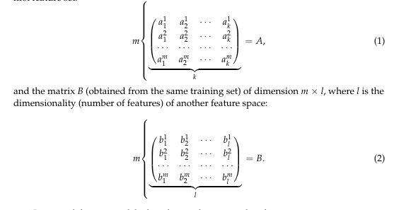
You have m cats.
- For each cat, you have k features in A → that’s Matrix A (size m × k).
- For each cat, you have l features in B → that’s Matrix B (size m × l).
Problem:
We want a conversion rule to go from A's description → B's description.
We want a matrix T such that:
￼
Here, T is k × l.
Multiply a cat's A-features by T, you get approximately its B-features.
if m = k = l, you could just do:
T=B×A^−1
(But here, m, k, l often differ, so A^−1may not exist.)
So we use pseudoinverse (a kind of “almost inverse” for non-square matrices).
T≈A+×B
Where A+A+ is the pseudoinverse of A.
- Simple case: If columns of A are independent,
A+ = (A^(T)A) ^(−1)A ^(T)
- If rows of A are independent,
A+ = A^(T) (AA^(T))^ −1
- General case (SVD method):
Break A into simpler parts, invert the non-zero parts, and combine back.
This works even if A is “singular” (det = 0).
In practice, if the specified conditions are met, the mentioned methods formalized yield the best results. To decide on the use of A+ = (A^(T)A) ^(−1)A ^(T), check that det(A ^(T) A) ̸ = 0. Also for A+ = A^(T) (AA^(T))^ −1, check that det (AA^(T)) ̸ = 0
In cases where it is not possible to obtain A+ with either conditions above, meaning det ATA = 0, det AAT = 0 or they are close to 0, it is proposed to determine A+ using SVD decomposition.
Once you have T, for a new cat’s A-features a∗a∗,
b∗=a∗×T
gives its predicted B-features.
- Another application of the transition matrix T is proposed, specifically for obtaining the coefficients of the hyperplane from points that belong to (or are close to) this hyperplane.
Imagine you have some points in 3D space (like stars in the sky).
Maybe they’re not perfectly aligned, but they roughly lie in a flat plane (like a sheet of paper in space).
We want the equation of that plane.
In math, the equation of a plane is:
w1x1+w2x2+w3x3+b=0
Here:
- x1,x2,x3 are coordinates of a point.
- w1,w2,w3,b are the coefficients we want to find.
- If you plug in a point that’s on the plane, the left-hand side equals 0.
If we have exactly 3 points in 3D, there is exactly one plane passing through them.
We can solve directly.
But here:
- They have mm points.
- Each point has mm coordinates (meaning the dimension equals number of points? This is unusual in practice, but maybe it’s a special case in their data).
- They plug each point (x1(j),x2(j),…,xm(j))(x1(j) ,x2(j) ,…,xm(j) ) into the plane equation:
w1x1(j)+w2x2(j)+⋯+wmxm(j)+b=0
Do this for mm points → You get mm equations.
That system is homogeneous (all equations = 0).
It has infinite solutions (scale ww and bb by any number, still works).
But we just need one set of coefficients.
They say: If a plane passes through points P1,P2,…,Pm , then for any point X=(x1,x2,…,xm) on that plane, the determinant
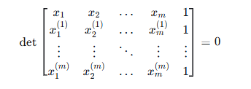
Why? Because if X is on the plane through P1,…,Pm , then X is linearly dependent with them in a certain way → determinant zero.
They then expand the determinant along the first row → get something like:
C1x1+C2x2+⋯+Cmxm+Cm+1=0
But this is exactly the plane equation w1x1+⋯+wmxm+b=0w1 x1 +⋯+wm xm +b=0
with wi=Ciwi =Ci and b=Cm+1b=Cm+1 .
So wiwi and bb are those signed minors (determinants of smaller matrices) from the expansion.
- If the points are in a special arrangement (e.g., some points are repeated, or they lie in a lower-dimensional subspace), the determinant can be zero for all choices → can't extract meaningful wi,bwi ,b.
When the math trick fails, they use an evolutionary algorithm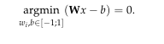 .
That’s basically:
- Randomly guess many possible (w1,…,wm,b)(w1 ,…,wm ,b).
- For each guess, measure how well w1x1(j)+⋯+wmxm(j)+bw1 x1(j) +⋯+wm xm(j) +b is close to 0 for all points.
- Keep the best guesses, mix them, mutate, repeat → evolution toward the best fit.
They search for wi,bwi ,b between -1 and 1 (to keep numbers small).
Materials and Methods
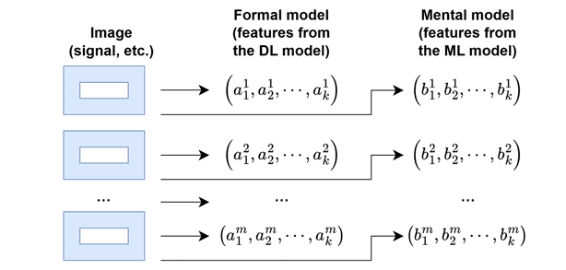
For this novel XAI approach, we make use of two DL models convolutional neural network and robustly optimized bidirectional encoder representations from transformers (RoBERTa). Due to ML being explained, the task of explaining the result of DL has now been done through ML. We consider a class of tasks where the input data are images, signals, etc, and the output information is the classification of these data into classes. Let us also assume that solutions to these tasks exist both through DL and ML means (for the same datasets). We consider the DL model as a formal model and the ML model as a mental model. This work proposes the use of transition matrix between two models of characteristic features presented as matrices, for the same input data. This approach allows for mapping a vector composed of FM features into a new feature vector, whose features are obtained from MM, thus serving as an interpretation of the problems solution. The task of explaining the results of DL is proposed to be achieved through transition matrix T and transformation. Matrix A is obtained as per structure from the penultimate layer of trained DNN, and Matrix B is obtained as per structure from a trained ML model.
Step 1: Using any VA tool designed for dimensionality reduction of the feature space (MDS), Graphical representations of vector as points on a plane are obtained.
Step 2: The possibility of using formulas list in the basic concepts for the calculation of A⁺ is explored
Step 3: The transition matrix T is calculated T ≈ A⁺B
Step 4: Using the obtained matrix T, it is calculated according to b∗ i =Ta∗ j , i=1,k, j=1,l. for all vectors of the FM vector space. The vectors obtained by b∗ i =Ta∗ j , i=1,k, j=1,l. are compared with the vectors of the MM space to ensure the validity of the obtained transition matrix T.
Output Information: The transition matrix T.
After obtaining the transition matrix T following the steps outlined above and after obtaining the solutions from the trained DL model, we use the formula b∗ i =Ta∗ j , i=1,k, j=1,l. to explain the results in form of MM

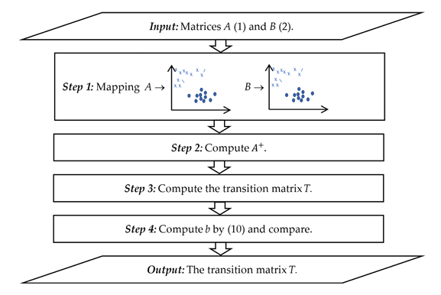

An example of this was done to try out the proposed methods, MDS was used on FM output of DL A and MM output of ML B
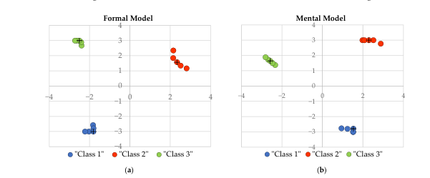

A⁺ and Transition matrix T were calculated. This was then used to estimate the result of MM B.

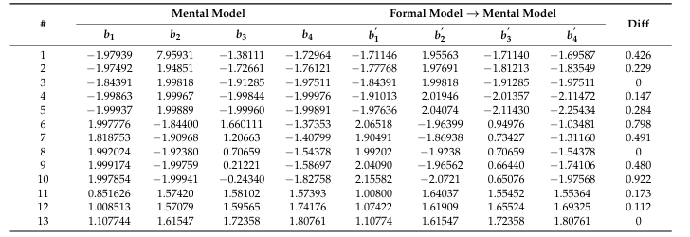
Diff shows the distance between the corresponding vectors in Euclidean space(similarity)

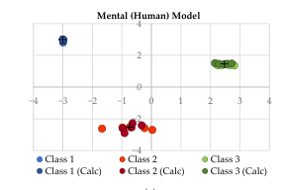
Plot of initial B and B¹ Calculated with the transition matrix
From the plot above, we can see an alignment between human-generated classifications and model-calculated estimations, thereby providing accuracy to the constructed transition matrix T in replicating human-like decision boundaries in a multidimensional feature space.
Obtaining a Separating Hyperplane using the Human-in-the-loop principle:
VA is often used for data exploration and analysis in classification tasks. The tool used in this research is MDS; this represents model objects in lower-dimensional spaces. With such approaches for models represented of n-dimensional feature vectors, corresponding feature vectors were obtained in Cartesian space. The authors propose an improved method for obtaining object coordinates in n-dimensional space based on coordinates in Cartesian space.

ExplAIner: A Visual Analytics Framework for interactive and explainable Machine Learning(https://arxiv.org/pdf/1908.00087)
This research focuses on interactive machine learning with explainable visual analytics, in these previous IML/VA procedures were classified according to how they cover three tasks of the AI pipeline. The paper emphasis why a general XAI system comprising all stages and task is needed to address the variance in interpretation of black box models. ExplAIner is a framework that operationalizes the theoretical workflow and concepts of XAI models in a system implementation. It is integrated on Tensor Board (TB), and provides interactive exploration of the model graph, on-demand aggregation and visualization of performance metrics as well as the integration of high-level explainers like LIME and LRP and even incorporates a global monitoring component such as user guidance. The pipeline is built around the tasks of understanding, diagnosis, and refining. Understanding is about knowing the internal architecture, diagnosis is about finding faults that the model has, and refinement is fixing model found during diagnosis. Finding the best model state to get optimal results, change is the state caused by transition function. Explainers are the main building blocks of the framework; they take the model state as input and generate explanation as visual map or surrogate model and then make a transition function. Explainers are specialized tools, and are not one size fits all hence they are defined on three critical levels, first is data coverage local explanation or global explanation, second abstraction which is the specific of explanation, low abstraction means it’s focused on mechanism of the model such as attention weights or high abstraction which is focused on the model as a whole. Dependency and explanation of usefulness might be dependent on domain outside, for instance, information useful in the medical field or automotive field. Multi-modal explainers take two model states and compare them.
A Multiscale visualization of attention in the Transformer Model (BERTVIZ)
Progress in NLP tasks since introducing the attention mechanism with the use of transformers. Recurrent networks were previously used, and lacked the ability to understand context, especially in longer sequences. The major challenge visualizing attention now are multiple attention heads producing different patterns in multiple layers. This paper introduces a high-level model view, which visualizes all the layers and attention heads in a single interface, and a low-level neuron view, which shows how individual neurons interact to produce attention. The tool comprises three views: attention-head view, model view, and neuron view. These views are used for the GPT-2 and BERT models, and they were applied in three use cases detecting model bias, locating relevant attention heads, and linking neurons to model behavior.
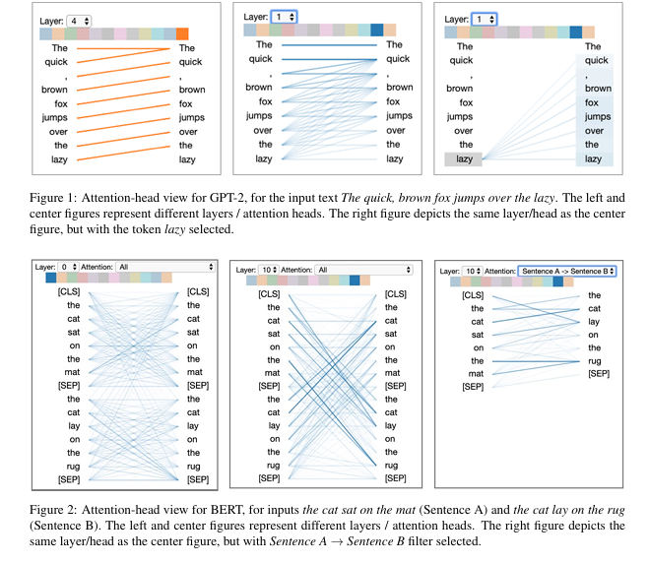
Attention-head view
Visualizes the attention patterns produced by one or more attention heads in each layer; attention is represented as lines connecting the tokens that are attending with the tokens being attended to. Colors identify the corresponding attention heads, while line weights reflect the attention score. Users can also filter attention by token, as shown in figure 1, in this case the target tokens are also highlighted and shaded based on the attention weight. Sentence-pair model is used for BERT; users can specify a sentence-level attention filter. Since attention heads do not share parameters, each attention head learns a unique attention mechanism.
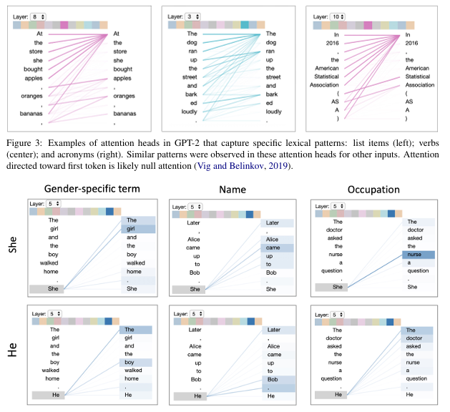
Besides positional patterns, attention heads also capture specific lexical patterns, such as those shown in figure 3. Other attention heads detected named entities, paired punctuation, subject-verb pairs, and other syntactic and semantic relations. Recent work work shows attention correlates with syntactic constructs such as dependency relations and part-of-speech tags.
Use case: Detecting Model Bias
Use case for attention-head view is the detection of bias in the model, which we illustrate for the case of conditional language generation using GPT-2. GPT-2 was asked to generate new words
- The doctor asked the nurse a question. She said, “I’m not sure what you’re talking about.”
- The doctor asked the nurse a question. He asked her if she ever had a heart attack.
This shows the models coreference mechanism may encode gender bias, The two examples are shown in figure 4 (right), which reveals she attended strongly to nurse, while he attends more to doctor.
Model view
The model view provides birds eye view of attention across all the model’s layers and heads for a particular input. Attention heads are represented in tabular form with rows representing layers and columns representing heads.
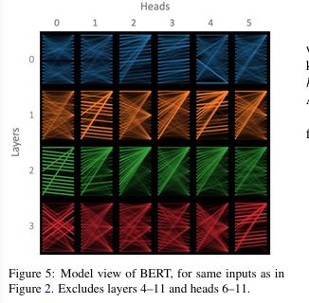

Users can also click on any head to enlarge tokens, and access attention head view.
Neuron view
The neuron view visualizes the individual neurons in the query and key vectors and shows how they interact to produce attention
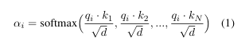
• Query q: The query vector of the selected token that is paying attention.
• Key k: The key vector of each token receiving attention.
• q×k (elementwise): The element-wise product of the query vector and each key vector. This shows how individual neurons contribute to the dot product (sum of element wise product) and hence attention.
• q·k: The dot product of the selected token’s query vector and each key vector.
• SoftMax: The SoftMax of the scaled dot product from the previous column. This is the attention score.

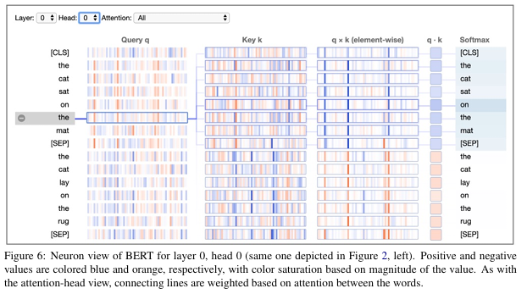
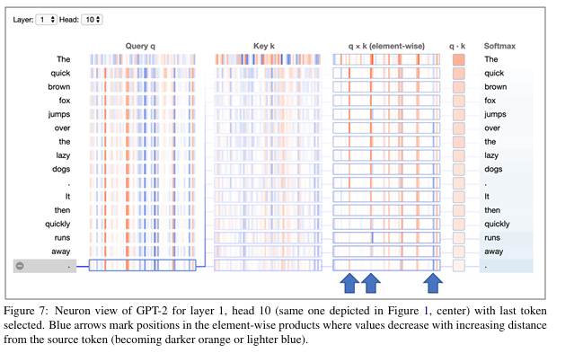
Use case: Linking Neurons to model Behavior
For attention head in Figure 7, the attention decays with increasing distance from the source token. This pattern resembles a context window, but instead of having a fixed cutoff, the attention decays continuously with distance. From the neuron, we’re able to get two key insights. First, the attention weights appear to be largely independent of the content of the input text, because all query vectors have very similar values (except for the first token). Second, a small number of neuron positions appear to be mostly responsible for the distance decaying attention pattern, at these neuron positions, the element-wise product q x k decreases as the distance from source token decreases (either becoming darker orange or lighter blue). One could intervene in the model by altering relevant neurons or adjusting attention weights and thus controlling the decay rate which might be useful when generating texts of varying complexity.

Transformer Visualization Via dictionary learning: contextualized embedding as a linear superposition of transformer factors. (Transformer Vis)
Transformers have had a major impact on NLP representation learning; however, our understanding of the representation is insufficient. This paper proposes dictionary learning techniques to open this black box as linear superpositions of transformer factors. Current technique used to interpret transformers is “Probing task”. This is done by attaching a light-weight auxiliary classifier at the output of the target transformer layer. The auxiliary classifier is then trained on well-known NLP tasks like part-of-speech (POS) tagging, Named-entity recognition (NER) Tagging, syntactic Dependency, etc. prior works show transformers have excellent performance in those probing tasks. The limitations of probing tasks are:
- POS and NER are too simple. A model that performs well in those probing tasks does not reflect the model’s true capacity
- Probing tasks can only verify whether a certain prior structure is learned in a language model. They can not reveal the structure beyond our prior knowledge.
- It’s hard to locate where exactly the related linguistic representation is learned in the transformer
In this work dictionary learning is proposed to solve the prior limitations of former transformer interpretation techniques.
The paper hypothesizes that contextualized word embedding as a sparse linear superposition of transformer factors. It proves that word embedding vectors can be factorized into sparse linear combination of word factors.
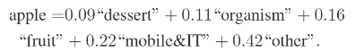
We collect a contextualized embedding of every word using a transformer model. We define the set of all word embeddings across all layers into a single set
X = X(1) U X(2) U ……U X(L)
By the hypothesis, embedding vector x ∈ X is a sparse linear superposition of transformer factor
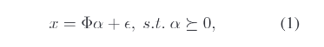
Where $Φ∝+R^{dxm}$ is a dictionary matrix with columns $Ф_{:,c}$, $∝∈ R^{m}$ is a sparse vector of coefficients to be inferred and ∈ is a vector containing independent Gaussian noise samples, which are assumed to be small relative to x. Typically m > d so that the representation is overcomplete.
An important method used in visualizing a feature in deep learning is to use the input samples, which trigger the top activation of the feature. Unfortunately, the hidden dimensions of transformers are not semantically meaningful. Instead, we try to visualize transformer factor $Ф_{:,c}$ and for a layer-l, we denote 1000 contextualized word vectors with the largest sparse coefficient $α_{c}(l)$ as $X_{c}(l)$ ⊂ $X(l)$, which corresponds to 1000 different sequences. For example, Figure 3 shows the top 5 words that activated transformer factor-17 :17 at layer-0, layer-2, and layer-6 respectively. Since a contextualized word vector is generally affected by many tokens in the sequence, we can use LIME to assign a weight to each token in the sequence to identify their relative importance to $α_{c}$. To determine low-, mid-, and high-level transformer factors with importance score, we build a single dictionary for all layers, A major question in representation learning is “Where does the network learn certain information?” To answer this question, we compute an importance score for each transformer factor as I_{c} . where I_{c} is the average of the largest 1000 sparse coefficients α_{c}, which corresponds to $X_{c}$. We plot the importance score each transformer factor as a curve shown in fig 2.
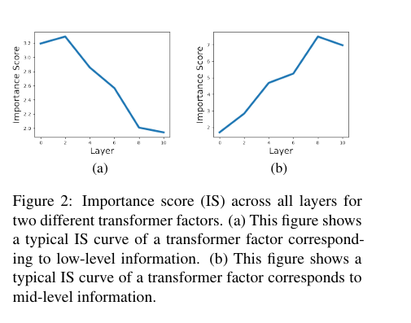

Experiments and discoveries
We use a 12-layer pre-trained BERT model and freeze the weights. Since we learn a single dictionary of transformer factors for all of the layers in the transformer, we show that these transformer factors correspond to different levels of semantic or syntactic patterns. word-level disambiguation, sentence-level pattern formation, and long-range dependency.
Low-level: word-level polysemy disambiguation : While the input embedding of a token contains polysemy, we find transformer factors with early IS curve peaks usually correspond to a specific word-level meaning. By visualizing the top activation sequences, we can see how word-level disambiguation is gradually developed in a transformer.
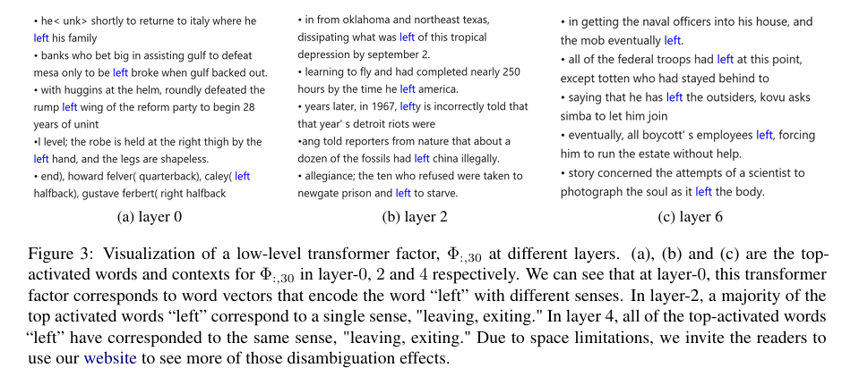
We also show more examples of those types of transformer factors in Table 1: for each transformer factor, we list out the top 3 activated words and their contexts in layer 4. As shown in the table, nearly all top-activated words are disambiguated into a single sense. Further, we can quantify the quality of the disambiguation ability of the transformer model.
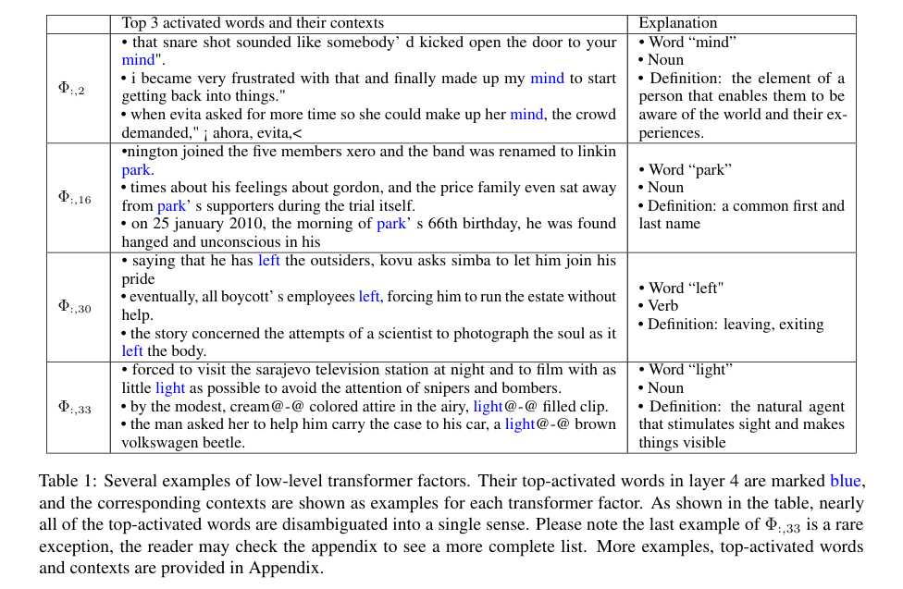
“left” with only the word sense “leave, exiting”, we can assume “left” when used as a verb, triggers higher activation in $Ф_{:,30}$, than “left” used as other sense of speech. We can verify this hypothesis using a human-annotated corpus: Brown corpus (Francis and Kucera, 1979). In this corpus, each word is annotated with its corresponding part-of-speech. We collect all the sentences contains the word “left” annotated as a verb in one set and sentences contains “left” annotated as other part-of-speech. As shown in Figure 4a, in layer 0, the average activation of :30 for the word “left” marked as a verb is no different from “left” as other senses. However, at layer 2, “left” marked as a verb triggers a higher activation of $Ф_{:,30}$, In layer 4, this difference further increases, indicating disambiguation develops progressively across layers.
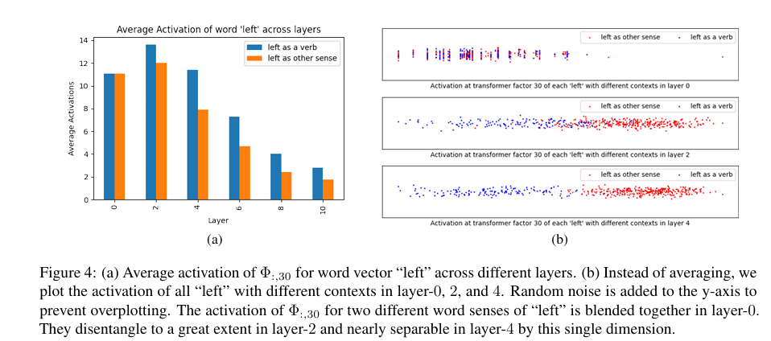
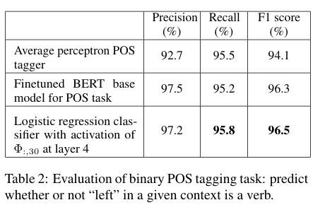
Mid-level: sentence-level pattern formation: We find most of the transformer factors, with an IS curve peak after layer 6, capture mid-level or high-level semantic meanings. In particular, the midlevel ones correspond to semantic patterns like phrases and sentences pattern. Figure 5 shows a transformer factor that detects the pattern of consecutive usage of adjectives. This pattern starts to emerge at layer 4, develops at layer 6, and becomes quite reliable at layer 8.
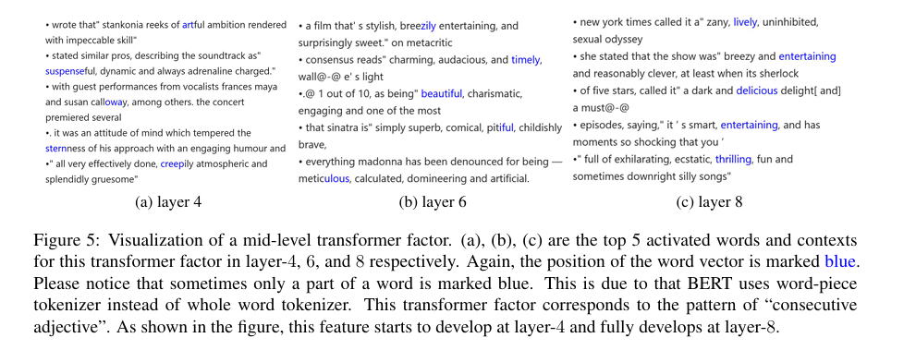
Figure 6 shows a transformer factor, which corresponds to an unexpected pattern: “unit exchange”, e.g., 56 inches (140 cm). Although this exact pattern only starts to appear at layer 8, the sub-structures that make this pattern, e.g., parenthesis and numbers, appear to trigger this factor in layers 4 and 6.
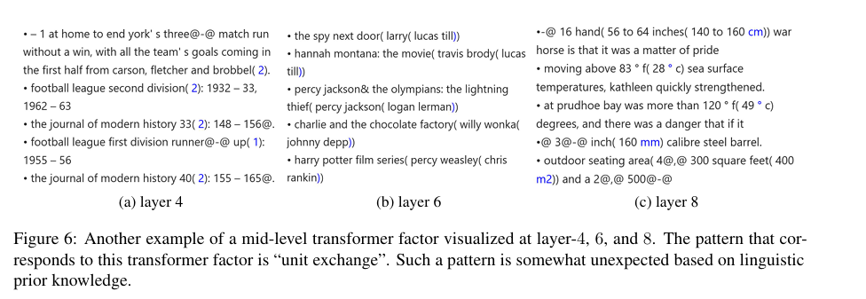
We list a few mid-level transformer activations Table3 with quantitative analysis. For each listed transformer factor, we analyze the top 200 activating words and their contexts in each layer. We record the percentage of those words and contexts that correspond to the factors’ semantic pattern in Table3.
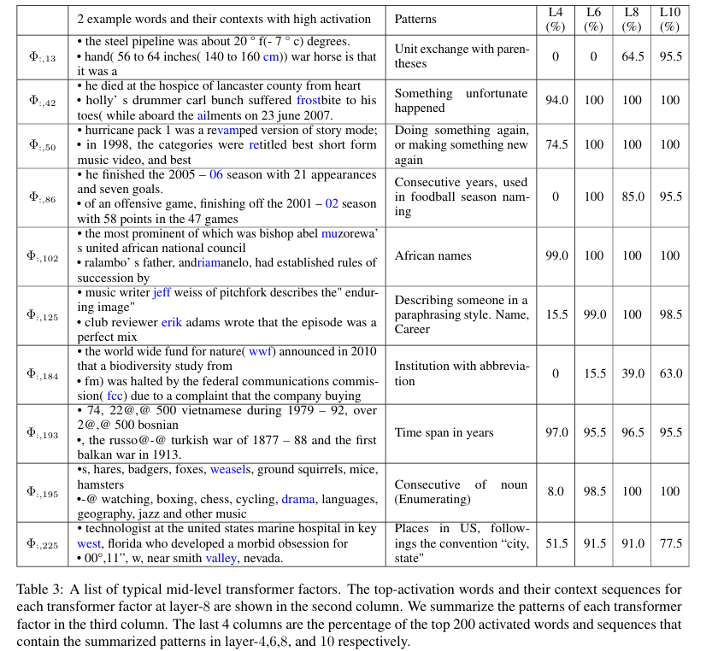
To further confirm a transformer factor does correspond to a specific pattern, we can use constructed example words and context to probe their activation. In Table 4, we construct several text sequences that are similar to the patterns corresponding to a particular transformer factor but with subtle differences.
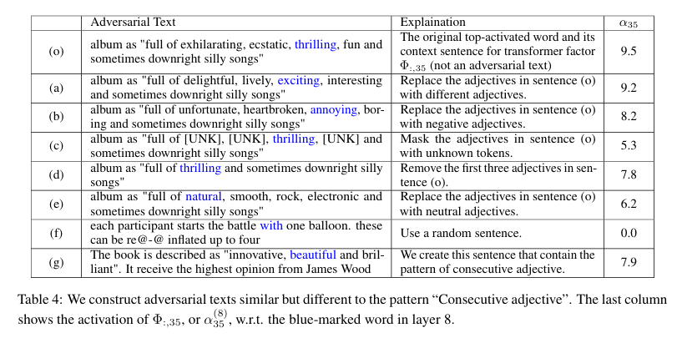
High-level: long-range dependency: High-level transformer factors correspond to those linguistic patterns that span an extended range in the text. Since the IS curves of mid-level and high-level transformer factors are similar, it is difficult to distinguish those transformer factors based on their IS cures. Thus, we must manually examine the top-activation words and contexts for each transformer factor to differentiate between mid-level and high-level transformer factors. This paper makes use of LIME to ease the process of identifying the contribution of each token in the sequence. Like in Figure 7, the color reflects the weights w at each position. Red means the given position has positive weight and green means negative weight. The magnitude of weight is represented by the intensity. The redder a token is, the more it contributions to the activation of the transformer factor. We leave more implementation and mathematical formulation details of LIME algorithm in the appendix.
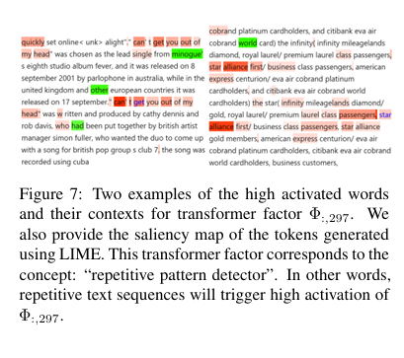
We name the pattern for transformer factor $Ф_{:,297}$in Figure 7 as “repetitive pattern detector”. All top activated contexts for $Ф_{:,297}$contain an obvious repetitive structure. Specifically, the text snippet “can’t get you out of my head" appears twice in the f irst example, and the text snippet “xxx class passenger, star alliance” appears three times in the second example. Compared to the patterns we found in the mid-level [6], the high-level patterns like “repetitive pattern detector” are much more abstract. The transformer detects if there are two (or multiple) almost identical embedding vectors at layer-10 without caring what they are.
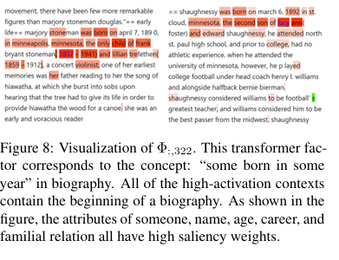
Figure 8 shown another high-level factor, which detects text snippets related to “the beginning of a biography”. The necessary components, day of birth as month and four-digit years, first name and last name, familial relation, and career, are all midlevel information.

Interpret: An Interactive Visualization Tool for Interpreting Transformers
With growing interest in the use of transformer models to understand NLP/NLU tasks, there is growing interest in understanding the inner workings of these systems. The paper contributes towards this goal by introducing a novel method for explainability and comprehension, with InterpreT. A key contribution of InterpreT is that it is a single system that enables users to track hidden representations of tokens throughout each layer of a transformer model, as well as visualize and analyze attention heads behaviors.
System design and workflow
The system flow consists of two major stages: offline extraction of the model specific and task specific information such as targets, predictions, relevant hidden states, and attention matrices and running the application itself. During the offline stage the extracted hidden states are preprocessed using t-SNE before being saved to a file.
Application Features
A Key feature of InterpreT include plots for the visualization and tracking of t-SNE representations of hidden states through the layers of a Transformer. A central component of t-SNE is the ability to visualize the contextualized embeddings of specific tokens throughout the layers of a transformer onto a two-dimensional space, creating disjoint t-SNE spaces for each layer of each model. T-SNE plot, token embeddings can be visualized for a specific model and layer.
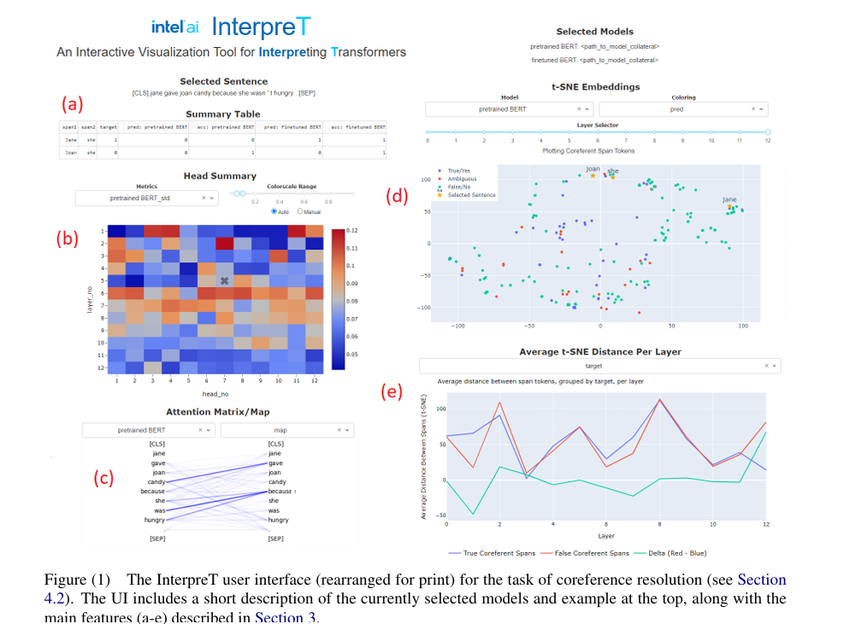
Head Summary
InterpreT includes a head summary plot that displays attention head summary statistics for each head and layer. For a given sentence, all attention weights are obtained in a matrix of size (num layers num heads sentence length sentence length) and compute statistics over the final two dimensions, yielding a summary plot of size (num layers num heads). The Standard Deviation of an attention head is generated by calculating the standard deviation of the corresponding attention matrix weights. Fig 1B
Attention Matrix Correlation
obtained by computing the correlation between an attention matrix and an arbitrary, same-size matrix.
Task-Specific Attention Intensity
a “coreference intensity” metric is devised to pinpoint attention heads with an affinity for identifying coreference relationships.
Attention Matrix/Map
InterpreT provides the ability to display the attention patterns and weights exhibited by specific attention heads, which can be selected by clicking on a specific head and layer in the head summary plot. These attention patterns can be displayed as either a heatmap or token map. Fig 1b to Fig 1c.
Average t-SNE Distance Per Layer
To complement t-SNE visualization of the hidden states, InterpreT also introduces a novel plot showing the average t-SNE space distance between specific groups of terms across all the Transformers’ layers, Fig 1e
Use Cases
Cross-Domain Aspect Based Sentiment Analysis (ABSA)
A fundamental task in fine-grained sentiment analysis is the extraction of aspect and opinion terms. For example, in the sentence “The chocolate cake was incredible”, the aspect term is chocolate cake, and the opinion term is incredible. In recent work (Pereg et al., 2020), externally generated dependency relations are integrated into a pre-trained BERT model through the addition. of a 13th attention head which incorporates the dependency relations into its Syntactically Aware Self-Attention Mechanism. This model is referred to as Linguistically Informed BERT (LIBERT). InterpreT is used to analyze LIBERT and a Baseline model that shares the same size and structure as LIBERT but does not incorporate syntactic information for the cross-domain ABSA task, where both models are fine-tuned on laptop reviews and are evaluated on restaurant reviews. LIBERT and the Baseline model achieved aspect extraction F1 scores of 0.5143 and 0.4254 respectively on validation data from the restaurant domain.
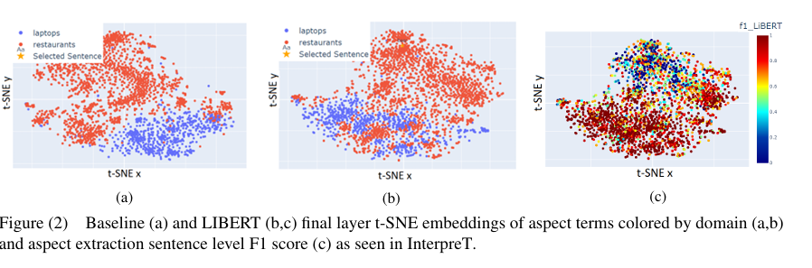
Visualizing the Domain Gap
InterpreT is used to visualize how the incorporation of dependency relations in LIBERT contributes to bridging the gap between domains. Figure 2 depicts the final layer aspect term t-SNE embeddings from the restaurant and laptop domains produced by LIBERT and Baseline. The plot of the Baseline embeddings (2a) gives a prototypical depiction of the “domain gap” challenge present in cross-domain setups, through the clear separation of in-domain (blue) and out-of-domain (red) aspects. Conversely, the plot of LIBERT’s embeddings (2b) demonstrates how LIBERT has learned to push the embeddings of some aspect terms from the out-of-domain region into the in-domain region, effectively overcoming the “domain gap” challenge for these examples. in the plot colored by the aspect extraction F1 score (2c), it is seen that LIBERT achieves a high F1 score on the out-of-domain examples that now overlap with in-domain examples, highlighting the usefulness of such visualizations for analyzing model performance and extensibility.
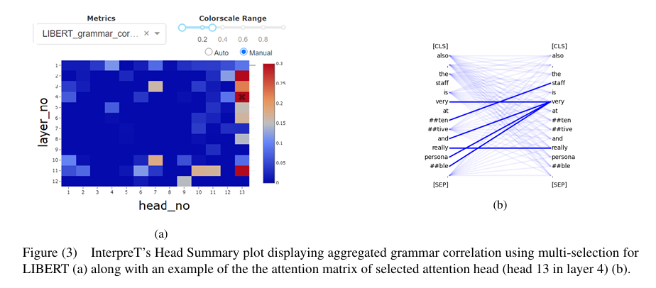

Grammar Correlation
A key feature of InterpreT is the addition of metrics to help identify attention heads which carry out specific functions. For analyzing LIBERT, the “grammar correlation” metric is used to identify attention heads with an affinity for detecting syntactic relations. Figure 3a demonstrates the result of using multi-selection to compute the average grammar correlation in each of LIBERT’s attention heads aggregated over multiple examples. As expected, the Syntactically Aware Self Attention head (head 13) tends to show much higher grammar correlation than the regular Self Attention heads. It is observed that LIBERT’s 13th head seems to only express an affinity for parsing syntactic relations in layers 2,3,4, and 11.
To investigate further, InterpreT can be used to display attention matrices from head 13 in layers that have high grammar correlation. One such attention matrix, for an out-of-domain example, is displayed in Figure 3b. In this attention matrix visualization, it can be seen how LIBERT’s 13th head identifies syntactic relations such as the adjectival modifier relation between “staff” and “attentive”, and how this can be useful for the cross-domain ABSA task where “staff” and “attentive” are aspect and opinion terms (respectively) in an out-of-domain example.

Coreference Resolution in the Winograd Schema Challenge (WSC)
In this section, the utility of InterpreT is showcased for a markedly different task: coreference resolution. Coreference resolution is a challenging NLP task that often requires a nuanced understanding of context and sentence semantics. This task is the basis of the Winograd Schema Challenge (WSC) from the SuperGLUE benchmark. where the goal is to determine whether a pronoun is the correct referent of a given noun phrase. In this analysis of WSC, InterpreT demonstrates how information in the attention matrices and the hidden states of a Transformer can be used to understand the implicit mechanisms contributing to its ability to identify coreferent terms. BERT-base (uncased) is chosen for this analysis and is fine-tuned using the WSC task training set.
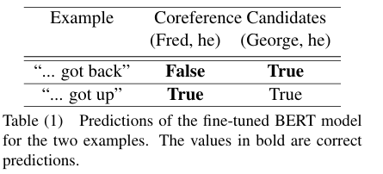

Spatial Convergence of Coreferent Terms
While analyzing WSC with InterpreT, the system’s wide-ranging capabilities gave rise to a novel observation, wherein it was discovered that a f ine-tuned BERT model pushes closer together the embeddings of terms it predicts to be coreferent. Figure 4a displays the average distance per layer between terms which BERT predicts to be coreferent (blue) and terms which BERT predicts to not be coreferent (red), aggregated over the full WSC dataset. It is observed that in BERT’s final layers, the model learns to modify the hidden representations of terms to increase or decrease the distance between them based on whether it predicts they are coreferents.
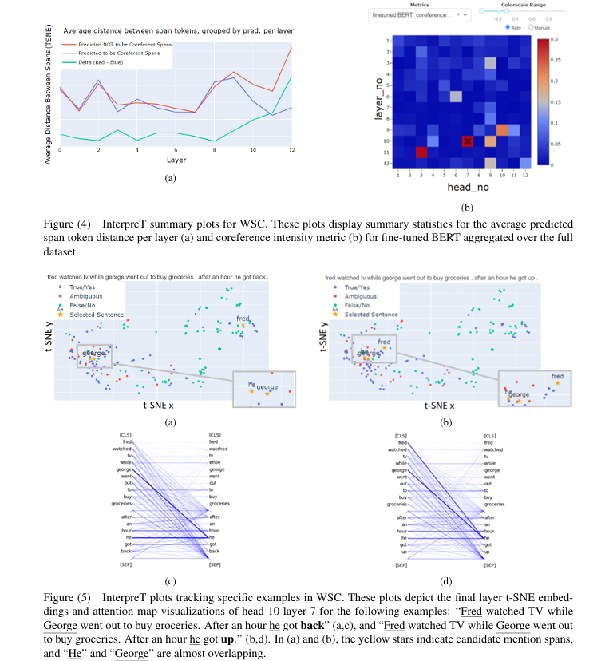

Additionally, Figures 5a and 5b show a specific example of this phenomenon with the sentences:
“Fred watched TV while George went out to buy groceries. After an hour he got back” (Figure 5a and Table 1) and “Fred watched TV while George went out to buy groceries. After an hour he got up.” (Figure 5b and Table 1). These two examples show how changing a single token (“back” became “up”) significantly alters the sentence semantics, as in the first example, “he” refers to “George”, and in the second example “he” refers to “Fred”. InterpreT enables us to visualize this behavior using the t-SNE plots. Figure 5a show how for the first example, “he” and “George” are much closer together than “he” and “Fred” are. Figure 5b shows how in the second example, the change from “he got back” to “he got up” is ref lected in BERT’s behavior, where the representation of “Fred” to be pushed much closer to “he” than in the first example.
Attention Patterns between Coreferent Terms
InterpreT can utilize custom metrics, such as the “coreference intensity”. Coreference intensity is visualized using the head summary plot in Figure 4b. The figure shows that the finetuned model highlights attention heads that seem to perform well as coreferent predictors. Darker shades of red correspond to higher attention between the two coreferents being evaluated. It appears that the heads which are the most involved in the coreference resolution task after fine-tuning are the 7th head of layer 10 and the 3rd head of layer 11.

DODRIO: Exploring Transformer Models With Interactive Visualization
Why do large pre-trained transformer-based models perform so well across a wide variety of NLP tasks? Recent research suggests the key may lie in multi-headed attention mechanism’s ability to learn and represent linguistic information. DODRIO tightly integrates an overview that summarizes the roles of different attention heads, and detailed views. Attention heads are comprised of weights incurred from words when calculating the next representation of the current word, which are known as attention weights. Easily interpretable, using attention to understand model predictions across domains is a very popular research area. Existing visualization systems and techniques do not visually connect attention mechanisms to linguistic knowledge.
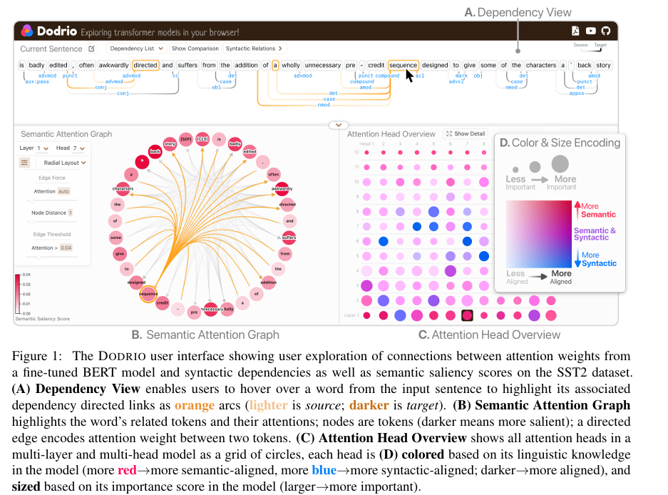
Attention Head Overview
As a user explores the attention weights, the Attention Head Overview (Figure 1C) serves as a guide to effectively navigate the remaining views of the interface. This view of a grid of attention heads guides the user to inspect semantically and syntactically important heads. Attention heads are encoded as circles where color encodes the head’s linguistic alignment (more red more semantic-aligned, more blue more syntactic-aligned; darker more aligned), and sized represents its importance score in the model (larger more important) (Figure 1B). We calculate the semantic score m by computing the cosine similarity between the sum of attentions received for each token at a given head, and the sentiment score of each token. If the sentiment score is not available in a dataset, we use the saliency score for each token instead.
Syntactic Dependencies
Word relations in a sentence are important features to understand the lexical makeup of a sentence, which can help users further deduce model decisions in the context of sentence structure.
Dependency View (Figure 1A): We visualize true dependency relations, if available, or relations tagged by the CoreNLP pipeline linked with the Semantic Attention Graph for users to investigate syntax-sensitive behavior at different attention heads. The user can further explore the dependency representation in a hierarchical structure by filtering dependency relations.
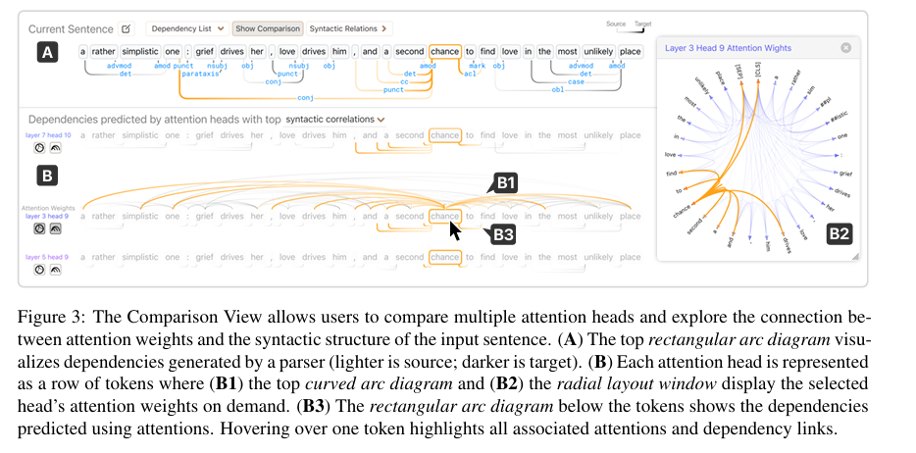
Comparison View (Figure 3). Understanding raw attention weights are best interpreted relative to the attention weights at other attention heads in the model. The Comparison View enables users to examine the dependencies predicted by attention heads (Figure 3-B3). By viewing the attention edges drawn above the tokens, which encode attention weight magnitude with opacity in the Arc Layout (Figure 3-B1), a user can maintain word order context in the sentence, while the attention representation utilizing a Radial Layout (Figure 3B2) of attention edges allows for a clearer interpretation the attention distribution.
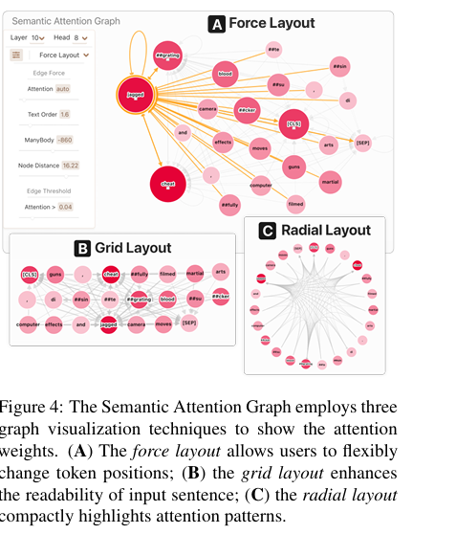
Semantic Attention Graph
Users can primarily use this interactive graph view to inspect semantically significant attention heads, as defined by the Attention Head Overview. Similarly to representations in Comparison View, the Semantic Attention Graph representations can be customized with interaction to allow for detailed attention inspection for selected tokens (Figure 4A), preserve token-order context in the Grid Layout (Figure 4B), or allow for clear attention analysis in the Radial Layout (Figure 4C).
Instance Selection View
For a robust understanding of the attention mechanisms in Transformers, it is important to explore the behavior of attention across interesting components of a sentence. The Embedding View (Figure S1-A) uses UMAP (McInnes et al., 2018) to project text instance’s model representation computed by concatenating the last four hidden state layers of BERT to a 2D space and visualizes it with a scatter plot. The Table View (Figure S1-B) allows for instance selection while providing the user with instance’s true and predicted labels. Users can hover over a dot in the Embedding View to view the sentence text, and click a dot or a row in the Table View to change DODRIO’s input sentence.
Case Study
Understanding Sentiment in BERT
we can explore the attention mechanism within a text instance from a movie review dataset, SST2 (Socher et al., 2013), such as “A coming-of-age film that avoids the cartoonish clich´es and sneering humor of the genre as it provides a fresh view of an old type.” When interpreting the sentence above, it is clear to us that “it” refers to the “film” because the first half of the sentence expresses positive sentiment towards the “film” and negative towards the “genre,” while the second half of the sentence represents a positive opinion on the “film.” By exploring the Attention Head Overview of DODRIO (Figure S3), we can select an attention head that conveys semantically significant information as indicated by the 2D color scale (eg. layer 1, head 7). As we begin to analyze the Semantic Attention Graph (Figure S3-left), we can hover over the node representing “it” to visualize the attention “It” attends highly to “film,”
Exploring DistilBERT
The computational barrier to achieve state-of-the-art performance on natural language tasks with large pre-trained Transformers like BERT (Devlin et al., 2019) was lowered when DistilBERT (Sanh et al., 2019), a smaller version of BERT, was presented. DistilBERT is 40% smaller and retains up to 97% performance compared to BERT with half as many self-attention layers.
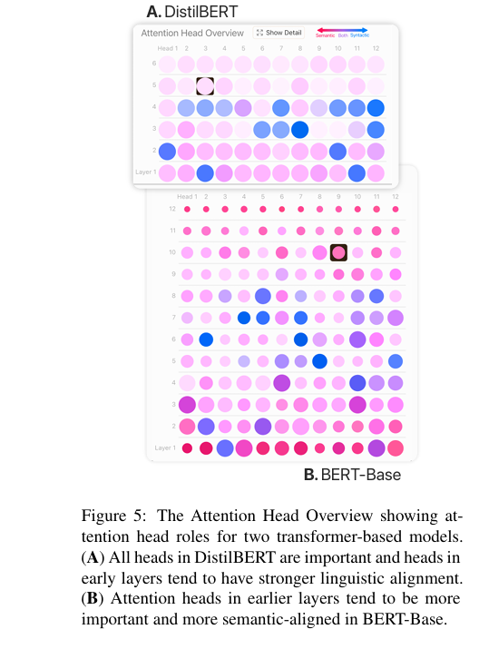
We can analyze attention mechanisms at various attention heads in DistilBERT to understand how attention compares to its larger version, BERT. Using the Attention Head Overview from DODRIO to visualize DistilBERT (Figure 5), we immediately notice that all radial attention head representations have the same diameter, unlike in the case of BERT. we recognize a similar pattern of syntactic and semantic attention heads, but in the later layers the attention head rings have a much higher luminance in DistilBERT than they did in BERT. According to the 2Dcolor scale (Figure 1D), this represents a lower overall score meaning that these attention heads neither attend to primarily text semantics of grammatical structure. It might imply that DistilBERT has learned some other linguistic knowledge beyond simple word semantics and syntactic dependencies.

BLIP: Bootstrapping Language-Image Pre-training for Unified Vision-Language Understanding and Generation
Modern Vision-Language pretraining falls into two categories
- Understanding-focused models (e.g., CLIP, ALBEF)
- Generation-focused models (e.g., SimVLM)
No model excels at both tasks, and most models rely on noisy web-scraped captions, which affects the learning quality. BLIP resolves these two problems.
BLIP is a new VLP framework which enables a wider range of downstream tasks than existing methods
- Multimodal mixture of Encoder-Decoder (MED): a new model architecture for effective multi-task pre-training and flexible transfer learning. An MED can operate either as a unimodal encoder, or an image-grounded text encoder, or an image-grounded text decoder.
- Captioning and Filtering: a captioner to produce synthetic captions given web images, and a filter to remove noisy captions from both the original web texts and the synthetic texts.
Modes of operation
Mode | Purpose | Activated By
Unimodal Encoder | Align image/text representations | Contrastive loss (ITC)
Image-grounded Text Encoder | Fine-grained image-text reasoning | Matching loss (ITM)
Image-grounded Text Decoder | Generate captions | Language Modeling loss (LM)

Pretraining Objectives
BLIP jointly optimizes:
- ITC – Aligns image/text embeddings
- ITM – Determines if an image-text pair matches
- LM – Text generation given an image
CapFilt: Smarter Use of Noisy Web Data
BLIP introduces Captioning + Filtering, a novel bootstrapping method.
CapFilt Pipeline
- Captioner (fine-tuned MED decoder)
  - Generates synthetic captions for web images using nucleus sampling (more diverse).
- Filter (fine-tuned MED encoder)
  - Removes bad/noisy captions (both original and synthetic) using learned image-text matching.
- Bootstrapped dataset =
human-annotated + filtered synthetic + filtered original web captions
The result is a cleaner, more diverse dataset, improving model performance across tasks.
Key Results
BLIP achieves state-of-the-art performance across many tasks.
Image-Text Retrieval
- Outperforms ALBEF by +2.7% Recall@1 using the same 14M pretraining images.
- Strongest zero-shot performance on Flickr30K.
Image Captioning
- Beats previous methods (e.g., VinVL, LEMON) despite using fewer resources.
- With ViT-L backbone, competitive with SimVLM (trained on 13× more data).
VQA
- Outperforms ALBEF by +1.6% VQA score.
- Comparable to or better than larger models with far more data.
NLVR2
- Strong performance (second only to ALBEF with extra pretraining).
Visual Dialog
- Achieves new SOTA on VisDial v1.0 validation set.
Zero-shot Video-Language Tasks
Huge generalization ability:
- Zero-shot text-to-video retrieval: 43.3% R@1, far above previous best (~18%).
- VideoQA: Dramatic improvements in zero-shot settings.
Insights
- CapFilt’s improvements are not from longer training time.
- Sharing encoder/decoder parameters except self-attention leads to best results.
- Captioner + filter must be decoupled, or else they overfit to each other.
- More diverse synthetic captions → better downstream performance.
- Bootstrapped dataset requires training a new model, not continuing the old one.

Recent Applications of Explainable AI (XAI): A Systematic Literature Review
Purpose of the Study
The authors conducted a systematic literature review of recent (2021–2024) applications of Explainable AI (XAI), analyzing 512 peer-reviewed journal articles.
Their goal was to answer three core research questions:
- Which domains are most actively using XAI?
- Which XAI techniques and explanation forms are used?
- How are XAI explanations evaluated?
1. Dominant Application Domains
The review shows massive growth of XAI across many fields, but healthcare overwhelmingly dominates.
Top domains:
- Healthcare & medicine (largest share by far)
  - Cancer diagnosis and prediction
  - COVID-19 detection, forecasting, ICU triage
  - Medical imaging (MRI, CT, X-ray, histopathology)
  - Neurological diseases (Alzheimer’s, Parkinson’s, epilepsy)
  - Brain tumor detection
  - Cardiovascular risk, diabetes prediction
- Environmental & agricultural systems
  - Earthquake prediction
  - Climate, water resources, soil moisture, crop disease detection
- Industrial & manufacturing
  - Predictive maintenance
  - Process optimization
  - Robotics fault diagnosis
- Cybersecurity & defense
  - Intrusion detection
  - Malware detection
  - Deepfake and voice spoof detection
- Finance
  - Credit risk assessment
  - Fraud detection
  - Loan approval
- Transportation & autonomous systems
- Education, psychology, legal, and social science (smaller but growing)
2. Most Common XAI Methods Used
Local explanations dominate (53% of papers), followed by mixed global+local (29%).
Very few papers use purely global explanations.
Most popular techniques:
- SHAP – by far the most used
  - Has mathematical guarantees (efficiency, symmetry, additivity)
  - Considered more stable than LIME
- LIME – widely used but criticized for instability
- Anchors – used far less frequently
For image data, the most used gradient-based methods include:
- Grad-CAM / Grad-CAM++
- SmoothGrad
- Integrated Gradients
- Layer-wise Relevance Propagation (LRP)
Global model-agnostic methods:
- Partial Dependence Plots (PDP)
- Accumulated Local Effects (ALE)
- Permutation Feature Importance
Intrinsic (ante-hoc) models:
- Decision trees
- Logistic regression
3. ML Models & Tasks Used
Across all papers:
Most used model families:
- Neural networks (59%)
- Tree-based models (37%)
- Support Vector Machines (11%)
- Logistic/Linear Regression (9%)
Main ML tasks:
- Classification – 70%
- Regression – 21%
- Clustering – 4%
- Reinforcement learning – 1%
Neural networks are most common in health, industry, environment.
Logistic regression is used more often in finance, where interpretability expectations are high.
4. Evaluation of XAI Methods is a Major Weakness
One of the strongest findings:
Most papers do NOT rigorously evaluate the quality of explanations.
Current issues:
- Heavy reliance on anecdotal interpretation
- Qualitative reasoning or expert opinion only
- Very few quantitative explainability metrics
- Lack of standardized evaluation frameworks
Authors’ conclusion:
There is an urgent need for standard evaluation metrics and best-practice frameworks before XAI can be considered reliable in high-stakes settings (e.g., medicine, finance, law).

Summary of the Paper: “Visual Analytics for Explainable AI”
1. Purpose and Motivation
The paper addresses the growing need for explainability in modern AI systems, especially deep learning models whose internal processes are highly opaque.
As AI is increasingly used in high-stakes domains (healthcare, finance, autonomous systems), understanding why an AI makes certain decisions becomes essential for trust, accountability, and regulation. Visual analytics is proposed as a key solution to bridge machine reasoning and human understanding.
2. What Is Visual Analytics in XAI?
Visual analytics combines:
- Interactive visual interfaces, and
- Algorithmic explanation techniques
to make model behavior interpretable. It leverages human cognitive strengths (pattern recognition, comparison, anomaly detection) to help users understand AI outputs.
Key theoretical pillars include cognitive fit, user interaction, and analytical reasoning.
3. Visualization Techniques for Explaining AI
The paper surveys a wide range of tools used to open the AI “black box”:
Local & Feature-Based Explanations
- Saliency maps (images)
- Heatmaps, feature attribution plots
- Layer-wise relevance propagation (LRP)
- Grad-CAM for deep networks These reveal which input features influenced predictions.
Global Structure & Behavior
- Dimensionality reduction (t-SNE, UMAP) to visualize internal model representations
- Decision trees & rule-based visuals for interpretable logic
- Performance dashboards (confusion matrices, ROC curves, error distributions)
Tools like TensorBoard and Microsoft InterpretML enable interactive debugging and exploration.
4. Domain-Specific Applications
Visual analytics supports explainability in:
Healthcare
Heatmaps on medical images help clinicians verify whether AI focuses on medically relevant regions.
Finance
Interactive dashboards help interpret credit scoring, fraud detection, and support compliance with GDPR and EU AI Act requirements.
Scientific Research
Enables exploration of molecular data, genomics, climate models, etc.
Across contexts, tools must be user-centric, adapting explanations to domain expertise.
5. Challenges Identified
The paper highlights several persistent issues:
Technical Challenges
- Difficulty visualizing high-dimensional, nonlinear model behavior
- Scalability issues for large models and big datasets
- Distortion risks in attribution and dimensionality reduction techniques
Ethical & Human-Factor Challenges
- Explanations can hide or amplify bias
- Diverse users require different types of explanations
- Risk of over-reliance or misinterpretation of visualizations
6. Evaluation & User-Centered Design
The paper stresses that evaluating XAI tools must go beyond numerical metrics.
Effective evaluation requires:
- User studies
- Task performance analysis
- Feedback on trust, usability, cognitive load
User-centered design (personas, prototypes, workflow integration) is essential for meaningful explanations.
7. Human-in-the-Loop (HITL) & Interactive Machine Learning
Visual analytics enables interactive collaboration where humans:
- Inspect model decisions
- Test hypotheses
- Adjust parameters or retrain models in real time
This supports continual model improvement but introduces design, reproducibility, and fairness concerns.
8. Future Directions
The authors highlight emerging research trends:
Multimodal AI
Visual tools must explain models combining text, images, audio, etc.
Generative AI & Foundation Models
New explanation challenges for large-scale models.
Standardized Explainability Metrics
Driven by policy and regulatory frameworks.
Responsible AI
Visual analytics will increasingly support fairness, accountability, and transparency in real-world deployments.
Overall Takeaway
The paper argues that visual analytics is a central pillar of Explainable AI, enabling humans to understand, validate, and collaborate with complex models.
While progress is significant, many challenges—scalability, bias, multimodality, user diversity—must be addressed for truly trustworthy and universal XAI solutions.

Phi-4-reasoning-vision-15B Technical Report
Phi-4-Reasoning-Vision-15B is an open-weight, compact (15B parameter) multimodal model designed to perform vision–language tasks with strong mathematical, scientific, and GUI-reasoning abilities. The core message is that careful data curation, mid-fusion architecture choices, and selective reasoning enable small models to approach or surpass the performance of larger models—with drastically lower compute and token budgets.
The paper contributes:
- A mid-fusion multimodal architecture combining SigLIP-2 and Phi-4-Reasoning.
- A high-resolution dynamic-resolution vision encoder for fine-grained perception.
- A mixed reasoning / non-reasoning training strategy enabling the model to “decide” when to think.
- An emphasis on extreme data quality improvements, including filtering, regeneration, augmentation, and error correction of open datasets.
- Evidence that small models can push the Pareto frontier in the accuracy-vs-compute tradeoff.
Key Points Explained
1. Motivation
Large VLMs increasingly depend on enormous datasets, long outputs, and computationally expensive reasoning. This limits deployment in real-world, interactive settings. Phi-4-Reasoning-Vision-15B seeks to be:
- Strong at reasoning,
- Efficient in inference,
- Competent across tasks including GUI grounding, OCR, math, science, and general VQA.
2. Architecture
Mid-Fusion Design
The model uses:
- SigLIP-2 as vision encoder,
- A learned MLP projector,
- The Phi-4-Reasoning LLM backbone,
- Interleaving visual tokens with text tokens.
This avoids the high cost of early fusion while still enabling strong multimodal grounding.
Dynamic-Resolution Encoder
The authors find:
- Higher-resolution tokenization strongly improves grounding tasks (e.g., ScreenSpot-Pro).
- Dynamic resolution (up to 3600 tokens) performs best. This is essential for agentic, GUI-intense tasks.
3. Training Pipeline
Training proceeds in three stages:
- MLP pretraining (align image–text spaces)
- Full instruction tuning (single-image, diverse tasks)
- Long-context, multi-image & RAI (responsible AI, safety, document tasks)
Each stage runs for one epoch—a notable design choice indicating emphasis on high-quality data over brute-force scale.
4. Data Quality Strategy
The paper heavily emphasizes data quality as the main performance lever. The authors:
- Remove low-quality data,
- Regenerate captions/answers,
- Repair formatting errors,
- Create synthetic reasoning-friendly data,
- Generate multi-image sequences for attention and grounding.
This aligns strongly with recent literature advocating “data-centric AI”.
5. Mixed Reasoning + Non-Reasoning
A major conceptual contribution is the dual-mode training strategy:
- Reasoning samples use <think>...</think> (chain-of-thought).
- Non-reasoning samples use <nothink> for direct answers. Reasoning is about 20% of the training mix.
This enables:
- Fast inference for simple visual tasks,
- Deep reasoning for math/science problems.
This idea mirrors human selective reasoning and is important for minimizing latency.
6. Evaluation
The model is benchmarked on many tasks:
- Math (MathVista, MathVerse, MathVision)
- Charts (ChartQA)
- Documents (OCRBench)
- GUI grounding (ScreenSpot)
- General multimodal reasoning (MMMU, AI2D)
Across these, the model:
- Outperforms models with similar compute budgets,
- Competes with (and in some cases surpasses) larger models,
- Achieves strong latency performance due to fewer output tokens.
Contributions of the Paper
1. A compact, efficient multimodal reasoning model
The authors demonstrate that a 15B model can match or outperform larger models through:
- Rigorous data filtering,
- Dynamic resolution perception,
- Efficient reasoning training.
2. Systematic ablation of vision encoder strategies
They compare:
- Dynamic S²,
- Multi-crop,
- Multi-crop + S²,
- Dynamic resolution.
Result: Dynamic resolution with large token budgets performs best.
3. Mixed-mode reasoning framework
A practical approach for controlling reasoning behaviour without reinforcement learning or excessive data.
4. Strong GUI grounding & computer-use abilities
Thanks to high-resolution perception and curated GUI datasets.
5. High-quality, curated open-source data pipeline
A data-centric contribution with broad value for the community.
Gaps in Research (Open Problems Identified in the Paper)
The authors explicitly state several unresolved problems:
Gap 1: Optimal resolution vs. efficiency tradeoff
Dynamic resolution improves performance but increases cost quadratically with tokens.
Open question: How to perform text-conditioned selective encoding (e.g., compress background, preserve problem area).
Gap 2: When should the model reason?
The boundary between reasoning and non-reasoning is still implicitly learned.
Problems:
- Sometimes reasons unnecessarily,
- Sometimes avoids reasoning when beneficial.
This is highly relevant to Explainable AI.
Gap 3: Optimal data proportions
The ratio between math, GUI, and general data is unresolved at larger scales.
Current observations are only at small-scale ablations.
Gap 4: Handling extreme data imbalance
Imbalance at very low representation (<1%) is an open research challenge.
Gap 5: Fine-grained image understanding remains limited
Authors admit limitations in:
- Extremely detailed perception,
- Highly nuanced visual understanding.
Gap 6: Safety in multimodal contexts
Safety alignment for visual content is still an emerging research area.
Future Work Suggested by the Paper
These are explicitly or implicitly proposed:
1. Text-conditioned adaptive vision tokenization
Encode only the relevant parts of an image at high resolution. This would reduce compute while maintaining accuracy.
2. Improving reasoning-mode switching
Develop mechanisms (possibly explicit classifiers or meta-controllers) to:
- Trigger reasoning only when needed,
- Avoid over- or under-thinking.
3. Large-scale experiments on data composition
Study data ratios at full model scale, not only the 5B ablation model.

4. Better grounding and high-resolution perception
Further explore:
- Multiscale encoders,
- Joint image–text attention,
- Early fusion efficiencies.

5. Enhanced safety for multimodal reasoning
Develop datasets and methods that handle:
- Adversarial images,
- Ambiguous or harmful visual content.

6. Release of training data
The authors state future intentions to release part of their data, which may enable reproducibility studies.
This paper presents a systematic study of the latent geometry of Transformer-based large language models (LLMs) using dimensionality reduction techniques such as PCA and UMAP. The authors develop a pipeline to capture, organize, and visualize latent states from multiple points inside Transformer blocks. They apply this methodology to GPT-2 and LLaMa-7B, uncovering previously undocumented geometric patterns in their internal representations.
The study aims to advance mechanistic interpretability by exploring how the internal activations of LLMs evolve across layers and sequence positions, what structures they form in high-dimensional space, and how different components (attention vs. MLP) contribute to that geometry.

Visualizing LLM Latent Space Geometry Through Dimensionality Reduction
High-Level Summary of the Paper
This paper presents a systematic study of the latent geometry of Transformer-based large language models (LLMs) using dimensionality reduction techniques such as PCA and UMAP. The authors develop a pipeline to capture, organize, and visualize latent states from multiple points inside Transformer blocks. They apply this methodology to GPT-2 and LLaMa-7B, uncovering previously undocumented geometric patterns in their internal representations.
The study aims to advance mechanistic interpretability by exploring how the internal activations of LLMs evolve across layers and sequence positions, what structures they form in high-dimensional space, and how different components (attention vs. MLP) contribute to that geometry.
Key Contributions
1. A full pipeline for extracting and visualizing LLM latent states
The paper develops a three-stage workflow:
- Latent state extraction from multiple capture points inside each Transformer block.
- Data processing (filtering, aggregation, and optional preliminary PCA).
- Dimensionality reduction & visualization using PCA/UMAP. This enables reproducible geometric analysis of LLM internals.

2. Discovery of a new geometric signature: MLP vs. Attention separation
The authors observe a clear geometric separation between the latent outputs of:
- Attention modules and
- MLP modules
Across many layers and in both GPT-2 and LLaMa, pre-add activations from attention vs. MLP components cluster into distinct regions in reduced space. This separation persists under PCA and UMAP. The authors note that this phenomenon has not been documented before.
3. Analysis of high-norm latent states at the initial sequence position
The 0-th token position (initial token) exhibits unusually high vector norms, even for normal vocabulary tokens in LLaMa. This:
- Appears across models,
- Persists despite using relative position encodings (RoPE),
- And impacts dimensionality reduction due to norm outliers.
This suggests models implement special mechanisms for the initial token.

4. Visualization of layerwise evolution of latent states
The paper shows:
- Latent state norms rise across layers,
- Peaks near the final transformer block,
- Drop after the final normalization layer. PCA visualizations reveal clear layerwise trajectories in latent space for both GPT-2 and LLaMa.

5. Geometric structure of positional information
The authors explore how sequence position affects latent geometry.
GPT-2 (learned embeddings):
- Exhibits a helical high-dimensional positional structure, consistent with prior findings.
- Visible across multiple PCA dimensions.
LLaMa (RoPE):
- Shows lower-dimensional geometric patterns,
- With early sequence positions forming long “tails” before converging,
- But less pronounced than GPT-2 because RoPE interacts differently with attention.

6. Repeating token experiment (new behavioral insight)
For LLaMa, repeated “e” tokens show:
- Convergence of latent states over long sequences,
- Later tokens drift toward a direction similar to the <BOS> token,
- Matching prior observations about “massive activations”.
This suggests RoPE-based models may normalize repeated contexts by compressing long repeated sequences into a stable representation.

Overall Findings
The paper demonstrates that latent space geometry reveals rich and interpretable structure within Transformer models. Key discoveries include:
- Distinct geometric regions for attention vs. MLP outputs.
- High-norm mechanisms for initial tokens.
- Clear layerwise evolution of representation geometry.
- Structured positional patterns in both embedding-based (GPT-2) and RoPE-based (LLaMa) models.
- Convergence behavior under repeated-token conditions.
These insights highlight the potential of geometric interpretability to illuminate LLM internal mechanisms.
Gaps & Future Research Directions
The authors point out several open challenges that create opportunities for future work:
1. Understanding the cause of attention vs. MLP geometric separation
Why do these components produce distinct representational subspaces? How does this relate to their functional roles?
2. Better explanation of high-norm initial token activations
This phenomenon persists even in RoPE models. Future work could uncover:
- Whether these norms encode universal context initialization,
- Or represent bias terms / global state activations.
3. Clarifying RoPE’s contribution to positional geometry
It's still unclear whether LLaMa’s observed patterns arise from:
- RoPE itself,
- Accumulating attention behavior,
- Or other architectural interactions.

4. Scaling geometric analysis to other architectures and LLM sizes
Including early-fusion models, multimodal transformers, mixture-of-experts, and reasoning models.
5. Developing more principled tools for feature-geometry interpretability
Dimensionality reduction provides intuition but lacks formal guarantees.
Future methods could incorporate:
- Causal probing,
- Subspace analysis,
- Feature decomposition techniques.

Attention is Not Explanation

1. Core Thesis
The paper challenges a widespread assumption in NLP:
Attention weights are not reliable explanations of model predictions.
Although attention mechanisms improve performance, the authors demonstrate that:
- They do not consistently reflect feature importance, and
- They do not uniquely explain model decisions.

2. Problem Formulation
The authors investigate whether attention provides faithful explanations by testing two necessary conditions:
(A) Correlation with Feature Importance
If attention is explanatory, it should align with:
- Gradient-based importance
- Leave-One-Out (LOO) feature importance
(B) Counterfactual Sensitivity
If attention explains predictions:
- Changing attention weights should change outputs
3. Methodology
Tasks & Models
- Tasks: Text classification, QA, NLI
- Models: Primarily BiLSTM + attention, with comparisons to CNN and “average embeddings”
- Datasets: SST, IMDB, SNLI, CNN QA, MIMIC, etc.
Key Experiments
1. Correlation Analysis
- Measure Kendall τ between attention weights and:
  - Gradient importance (τg)
  - Leave-one-out importance (τloo)
2. Attention Perturbation (Permutation)
- Randomly shuffle attention weights
- Observe output change
3. Adversarial Attention
- Construct maximally different attention distributions
- Constrain them to produce same prediction
4. Key Findings
4.1 Weak Correlation with Feature Importance
- Attention weights show low and inconsistent correlation with gradients and LOO scores
- Typical correlations:
  - Often < 0.5, sometimes near zero
- Stronger correlations only in simpler models (non-contextual encoders)
Interpretation:
- Attention ≠ feature importance
- It does not reliably identify causal input features

4.2 Output Invariance to Attention Changes
- Permuting attention weights often produces minimal output changes
- Even large redistribution of attention:
  - Causes negligible prediction difference (~0.006 in examples)
Implication:
- Model predictions do not depend strongly on attention weights

4.3 Existence of Adversarial Attention
- Authors construct attention distributions that:
  - Are very different (high JSD divergence)
  - Produce almost identical outputs
Key insight:
Multiple radically different “explanations” can justify the same prediction.

4.4 Attention Heatmaps Can Be Misleading
- Visual attention explanations (heatmaps):
  - Suggest causal importance
  - But are non-unique and manipulable

5. Theoretical Implications
5.1 Attention Is Not Causal
- Attention is a mechanism for representation weighting, not:
  - Attribution
  - Causal explanation
5.2 Interpretability vs Plausibility
- Attention provides plausible narratives, not faithful explanations
- Distinction:
  - Plausible explanation: looks reasonable
  - Faithful explanation: reflects true causal mechanism
Limitations
1. Proxy Measures of Importance
- Uses gradients and LOO as “ground truth”
- These are themselves:
  - Imperfect
  - Hard to interpret in deep networks

2. Model Scope
- Focus on:
  - BiLSTM with soft attention
- Does not cover:
  - Transformer-based attention (important today)
  - Structured or sparse attention variants

3. Task Scope
- Evaluates:
  - Classification, QA, NLI
- Excludes:
  - Seq2seq tasks (e.g., translation)

4. Adversarial Attention Realism
- Constructed attention distributions:
  - May be unlikely under the trained model
- Raises question:
  - Are all explanations equally plausible in practice?

5. Metric Limitations
- Use of Kendall τ:
  - Sensitive to noise
  - Affected by irrelevant tokens

Research Gaps
1. Causal Interpretability of Attention
- No formal causal framework connecting:
  - Attention → prediction
2. Transformer Attention
- Paper predates large-scale transformer interpretability debates
- Leaves open:
  - Are findings transferable to transformers?
3. Multi-Explanation Frameworks
- The existence of multiple valid explanations suggests:
  - Need for sets of explanations, not single heatmaps
4. Human Alignment
- Does attention align with:
  - Human reasoning?
- Not deeply explored

Future Research Directions
1. Design of Interpretable Attention
- Sparse attention (e.g., hard selection)
- Structured attention
- Rationalized attention (human-guided)

2. Causal Interpretability Methods
- Integrate:
  - Causal inference
  - Intervention-based evaluation
- Example direction:
  - Counterfactual token manipulation frameworks

3. Post-hoc Explanation Methods
- Combine attention with:
  - Integrated gradients
  - SHAP / LIME
- Hybrid interpretability frameworks

4. Transformer-Specific Studies
- Extend analysis to:
  - Multi-head attention
  - Attention flow / attention rollout
  - Mechanistic interpretability

5. Evaluation Protocols
- Develop formal metrics for explanation faithfulness
- Move beyond correlation-based validation

6. Explanation Uncertainty
- Model explanations as:
  - Distributions over possible rationales
- Capture:
  - Ambiguity
  - Non-uniqueness of explanations

Key Contributions
- First systematic empirical challenge to the claim:
  - “Attention = explanation”
- Introduced:
  - Adversarial attention framework
- Demonstrated:
  - Non-uniqueness of attention-based explanations
- Sparked:
  - Major research shift in interpretability
Attention is not not Explanation
1. Core Research Question
The paper critically revisits the claim by Jain & Wallace (2019) that:
“Attention is not explanation.”
It asks:
- Under what definitions of explanation can attention be considered explanatory?
- Are prior empirical tests of attention’s explanatory power methodologically sound?
2. Methodology
The authors adopt a model-driven, empirical + conceptual framework consisting of four main experimental probes:
(1) Uniform Attention Baseline (3.2)
- Replace learned attention weights with uniform weights.
- Purpose: test whether attention is actually necessary for performance.

(2) Variance Analysis (3.3)
- Train multiple models with different random seeds.
- Measure natural variability in attention distributions.
(3) Diagnostic MLP Framework (3.4)
- Introduce a non-contextual MLP using:
  - Fixed attention distributions as input weights
- Compare:
  - Learned attention
  - Uniform attention
  - Adversarial attention
Purpose: test model-agnostic usefulness of attention distributions.

(4) Model-Consistent Adversarial Training (4)
- Train a second model with objective:
$$L=\text{TVD}(y_{a},y_{b})-λ KL(α_{a}∥α_{b})$$
- Goal:
  - Keep predictions similar
  - Force attention distributions to diverge
Unlike Jain & Wallace:
- Uses parameterized, consistent models
- Avoids per-instance manipulation

3. Key Contributions
1. Critique of Prior Work
- Shows Jain & Wallace rely on:
  - Detached attention distributions
  - Per-instance adversarial perturbations
- Argues this breaks model coherence
2. Reframing of “Explanation”
- Distinguishes:
Concept | Meaning
Interpretability | Faithful causal understanding
Explainability | Plausible post-hoc rationale
Key claim:
Attention may still be valid as a plausible explanation, even if not uniquely faithful.
3. New Diagnostic Framework
- Introduces MLP-based evaluation of attention
- Provides:
  - A functional test of attention usefulness
  - A model-agnostic interpretability probe
4. Model-Consistent Adversarial Analysis
- First to demonstrate:
  - Adversarial attention must be learned via trained models, not arbitrary perturbations
- Reduces degrees of freedom in explanation testing
5. Empirical Evaluation Protocol
Provides a suite of tests:
- Necessity test (uniform baseline)
- Stability test (variance)
- Utility test (MLP diagnostic)
- Robustness test (consistent adversaries)
4. Key Findings
1. Attention is sometimes unnecessary
- In some datasets (e.g., AG News, 20 News):
  - Uniform attention performs similarly to learned attention
Implication:
- Explanation is meaningless if the mechanism is not functionally important
2. Attention shows natural variability
- Different random seeds produce different attention distributions
Weakens:
- Claims that adversarial examples alone invalidate attention
3. Learned attention is informative
- In diagnostic MLP:
  - Learned attention > learned MLP weights > uniform
Suggests:
- Attention encodes meaningful token importance
4. Adversarial attention is weaker than claimed
- When constrained properly:
  - Harder to generate extreme adversarial distributions
- Adversarial attention:
  - Performs poorly in the MLP diagnostic
Interpretation:
- Adversarial explanations are less useful and less plausible
5. Trade-off between prediction and attention divergence
- Increasing divergence (JSD) leads to:
  - Increasing prediction error (TVD)
Key insight:
- Attention is not arbitrarily manipulable in a realistic setting
5.Limitations
1. Narrow model class
- Focuses on:
  - LSTM + additive attention
- Does not cover:
  - Transformers or self-attention architectures
2. Task restriction
- Mostly:
  - Binary classification tasks
- Limited generalization to:
  - Structured prediction, QA, generation
3. No human evaluation
- Evaluation is:
  - Functionally grounded only
- Missing:
  - Human judgment of explanation quality
4. Proxy-based interpretation
- MLP diagnostic assumes:
  - Transferability of attention importance across architectures
6. Future Research Directions
The paper explicitly and implicitly proposes:
1. Extend beyond RNNs
- Apply framework to:
  - Transformers
  - Multi-head self-attention
2. Human-grounded evaluation
- Combine:
  - Functional metrics + human judgments
3. Broader task domains
- Explore:
  - QA, NLI, sequence generation
4. Theoretical grounding
- Develop:
  - Formal definitions of faithful vs plausible explanations
5. Dataset-dependent interpretability
- Study:
  - When attention is genuinely informative vs redundant
7. Conceptual Takeaway
The central philosophical conclusion:
Attention is not a universally faithful explanation but it can still be a meaningful, useful, and valid explanatory signal depending on how explanation is defined.

8. One-Sentence Thesis
The paper demonstrates that claims against attention as explanation are overstated by flawed experimental assumptions, and that when evaluated with coherent, model-consistent methods, attention retains meaningful though limited explanatory value.

Eliciting Latent Predictions from Transformers with the Tuned Lens
1. Research Problem & Motivation
The paper addresses a central interpretability question:
How do transformer models refine predictions across layers, and how can we faithfully extract and interpret these intermediate predictions?
Existing tools (notably the logit lens) attempt to decode hidden states into token predictions, but suffer from:
- Bias and unreliability
- Representational drift across layers
- Poor generalization to modern architectures (e.g., BLOOM, GPT-Neo)
The authors propose a principled alternative to understand transformers as iterative inference systems, where each layer incrementally refines a latent prediction.

2. Methodology
🔹 2.1 Conceptual Framework: Iterative Inference
- Each transformer layer updates a representation: $h_{l+1}=h_{l}+F_{l}(h_{l})$
- The model is interpreted as:
  - Maintaining a latent prediction distribution
  - Refining it layer-by-layer toward the final output

🔹 2.2 Baseline: Logit Lens
- Decodes intermediate representations using:
  - Final layer unembedding matrix
- Assumes hidden states are already aligned with final representation space
Problems identified:
- High KL divergence (bias)
- Poor predictive accuracy (high perplexity)
- Fails across architectures due to representation mismatch
🔹 2.3 Proposed Method: Tuned Lens
Core Idea:
Learn a layer-specific affine transformation (“translator”):
$${\text{TunedLens}}_{l}(h_{l})=\text{LogitLens}(A_{l}h_{l}+b_{l})$$
- Aligns intermediate representations with final-layer space
- Trained via distillation loss:
$$min⁡D_{KL}(\text{final logits }∥\text{ lens logits})$$
🔹 2.4 Causal Evaluation Framework
(a) Causal Basis Extraction (CBE)
- Identifies directions in hidden space that:
  - Maximally influence predictions
- Uses iterative optimization with orthogonality constraints
(b) Causal Faithfulness Tests
Two criteria:
- Feature importance alignment
- Stimulus-response alignment
Measured via:
- KL divergence after ablation
- Aitchison geometry for distributional similarity
🔹 2.5 Experimental Setup
- Models: GPT-Neo, Pythia, BLOOM, OPT (up to 20B parameters)
- Metrics:
  - Perplexity
  - KL divergence (bias)
  - AUROC (for applications)
  - Spearman correlation (difficulty estimation)
3. Key Contributions
1. Tuned Lens Framework
- Introduces learned translators per layer
- Resolves major limitations of logit lens:
  - Bias
  - Representation mismatch
  - Poor interpretability
2. Iterative Inference Perspective
- Formalizes transformers as:
Layer-wise refinement processes of latent predictions
3. Causal Basis Extraction (CBE)**
- Novel method for:
  - Identifying causally relevant features
- Moves beyond correlation-based probing
4. Causal Validation of Interpretability
- Demonstrates:
  - Strong alignment between tuned lens features and actual model behavior
- Establishes causal fidelity of probes, addressing a major critique of probing methods
5. New Applications of Interpretability
- Prompt injection detection
- Example difficulty estimation
- Secret knowledge elicitation
4. Key Findings
🔹 1. Tuned Lens significantly outperforms Logit Lens
- Lower perplexity across models
- Much lower KL divergence (bias)
- More stable and interpretable prediction trajectories
🔹 2. Prediction trajectories converge smoothly
- Intermediate predictions:
  - Gradually approach final outputs layer-by-layer
- Supports iterative inference hypothesis
🔹 3. Logit Lens is systematically biased
- Bias up to 4–5 bits KL divergence across layers
- Often predicts:
  - Input tokens instead of meaningful outputs
🔹 4. Causal alignment is strong
- Features extracted via tuned lens:
  - Strongly correlate with model-relevant features
(Spearman ρ ≈ 0.89)
Indicates:
- The tuned lens captures true causal structure, not spurious correlations
🔹 5. Intermediate layers can outperform final layer (under noise)
- Early/mid layers:
  - More robust to incorrect demonstrations
- Suggests:
  - Later layers may overfit or “overthink”
🔹 6. Security & robustness applications
- Tuned lens trajectories detect prompt injection attacks
  - Near-perfect AUROC on several tasks
🔹 7. Prediction depth correlates with example difficulty
- Deep-layer convergence ↔ difficult samples
- Strong correlation with:
  - “Iteration learned” metric
5. Limitations
1. Requires training probes
- Unlike logit lens:
  - Not plug-and-play
- Needs:
  - Data
  - Optimization per layer
2. Computational cost
- CBE is expensive:
  - Sequential optimization over high-dimensional space
- Does not scale easily to:
  - Very large models or many layers
3. Modality limitation
- Focused only on:
  - Language models
- Not evaluated for:
  - Vision transformers or multimodal models
4. Partial interpretability coverage
- Captures:
  - Token-level prediction dynamics
- Does not fully explain:
  - Internal circuits/mechanisms

5. Dependence on final-layer distillation
- Assumes:
  - Final logits are ground truth for intermediate decoding
- May obscure:
  - Alternative representational structures
6. Future Research Directions
1. Scaling causal interpretability
- Improve efficiency of:
  - CBE (e.g., subspace optimization)
2. Cross-modal generalization
- Apply tuned lens to:
  - Vision transformers
  - Multimodal architectures

3. Mechanistic interpretability integration
- Combine with:
  - Circuit-level analysis
  - Feature-level decomposition
4. Real-time monitoring tools
- Use tuned lens for:
  - Safety monitoring
  - Alignment tracking during inference
5. Deeper theoretical grounding
- Formalize:
  - Iterative inference interpretation
7. Conceptual Takeaways
🔹 Transformers as iterative refinement systems
- Layers:
  - Do not compute independent transformations
  - Perform progressive belief updates
🔹 Importance of representation alignment
- Interpretability requires:
  - Matching internal representations to output space
- Raw decoding (logit lens) is fundamentally flawed
🔹 Toward causal interpretability
- The paper moves the field from:
  - Correlation-based probing → causal validation

Knowledge Graphs, Large Language Models, and Hallucinations
1. Research Problem & Scope
The paper addresses a central and pressing issue in modern NLP:
How can hallucinations in Large Language Models (LLMs) be mitigated using Knowledge Graphs (KGs)?
- Hallucinations: factually incorrect but plausible outputs
- Key issue: undermines trust, reliability, and deployment in high-stakes domains (e.g., healthcare, law)
The paper is a position/survey paper, synthesizing:
- Hallucination detection methods
- KG-based grounding techniques
- Evaluation benchmarks
- Open research challenges
2. Methodology
The paper’s methodology is analytical and taxonomic, not experimental.
🔹 2.1 Literature Synthesis
- Reviews:
  - Hallucination detection methods
  - KG–LLM integration approaches
  - Benchmarks for hallucination evaluation
🔹 2.2 Proposed Taxonomy (Key Contribution)
The authors classify KG integration into LLMs into three stages:
(1) Pretraining
- Inject KG triples into training data
- Examples:
  - Masked entity prediction
  - Adapter-based knowledge modules
(2) Inference-Time Integration
- Typically via:
  - Prompting (RAG-style)
  - Context injection
- Limitations:
  - Prompt sensitivity
  - Context-window constraints
(3) Post-generation (Retrofitting)
- Pipeline:
  - Generate → extract claims → verify with KG → correct output
🔹 2.3 Evaluation Analysis
- Critically examines:
  - Existing datasets (e.g., TruthfulQA, HaluEval, MuShroom)
  - Metrics:
    - BERTScore, BARTScore
    - Entailment models
Identifies major gaps in evaluation methodology.
3. Key Contributions
1. Unified Perspective on LLM Hallucinations
- Provides a structured view of:
  - Types of hallucinations
  - Challenges in detection and mitigation
2. KG–LLM Integration Taxonomy
- Formal classification of:
  - Pretraining
  - Inference-time
  - Post-generation approaches
Clarifies design space for factuality-enhanced LLM systems
3. Critical Analysis of Evaluation Benchmarks
- Identifies limitations:
  - Mostly English-only datasets
  - Lack of fine-grained annotations
  - Absence of:
    - KG-structured context
    - multi-prompt evaluation
4. Identification of Open Challenges
- Highlights fundamental research gaps:
  - Detection granularity
  - Scalability of KG integration
  - Reliability of evaluation
5. Argument for KG-based Grounding
- Positions KGs as:
  - Structured, verifiable knowledge sources
  - Enabling:
    - Interpretability
    - Traceability of model outputs
4. Key Findings
🔹 1. Hallucination is inherent and unavoidable
- Prior work suggests:
  - Hallucinations cannot be fully eliminated
- Mitigation (not elimination) is the realistic goal
🔹 2. KGs provide strong factual grounding
- Advantages:
  - Structured knowledge (entities + relations)
  - Traceability of outputs
  - External verification capability
🔹 3. Prompt-based approaches are fragile
- Issues:
  - Sensitive to phrasing
  - Inefficient use of context
  - Limited by token window Leads to unstable factual grounding
🔹 4. Current detection methods are insufficient
- Multi-stage pipelines:
  - Vulnerable because they rely on LLM outputs at each step
- Lack:
  - scalability
  - robustness
🔹 5. Evaluation is a major bottleneck
- Current benchmarks:
  - Mostly response-level
  - Miss fine-grained hallucination spans
- Few datasets support:
  - multilingual evaluation
  - multi-prompt robustness testing
🔹 6. Fine-grained detection is critical
- Hallucinations can be:
  - subtle (single word / phrase)
- Need:
  - sentence-level or span-level detection
🔹 7. Multilingual challenges are underexplored
- LLMs:
  - perform worse in low-resource languages
- KGs:
  - could bridge knowledge gaps across languages
5. Limitations (of Existing Work & This Study)
1. Dependence on LLM pipelines
- Many methods rely on:
  - LLM-based extraction, verification, reasoning→ introduces compounding errors
2. Lack of robust evaluation frameworks
- No:
  - unified metrics
  - standardized benchmarks
- Evaluation often:
  - shallow and unreliable
3. Static knowledge injection
- Pretraining-based KG integration:
  - cannot keep up with dynamic knowledge updates
4. Prompting limitations
- Fragile to:
  - formatting
  - prompt engineering choices
- Limited interpretability
5. Dataset limitations
- Lack of:
  - multilingual datasets
  - KG-integrated evaluation data
  - training splits for KG-based methods
6. Lack of compositional analysis
- Limited research on:
  - combining multiple mitigation strategies
6. Future Research Directions
The paper explicitly outlines six major directions:
🔹 6.1 Large-scale KG-enhanced datasets
- Include:
  - KG triples
  - train/dev/test splits
- Support:
  - parametric knowledge integration
🔹 6.2 Robust evaluation frameworks
- Must cover:
  - multilinguality
  - multi-task scenarios
  - multi-prompt robustness
🔹 6.3 Fine-grained hallucination detection
- Focus:
  - token/span-level errors
- Enables:
  - precise correction
🔹 6.4 Beyond prompt-based integration
- Develop:
  - parameter-efficient methods
  - architecture-level integration
🔹 6.5 Hybrid mitigation strategies
- Study:
  - combinations of:
    - KG grounding
    - uncertainty modeling
    - decoding constraints
🔹 6.6 Multilingual knowledge integration
- Improve:
  - low-resource language performance
- Leverage:
  - multilingual KGs
7. Conceptual Insights
🔹 1. Shift from “model-only” to “model + knowledge”
- LLMs alone:
  - insufficient for factual reliability
- Need:
  - external structured knowledge
🔹 2. Interpretability via structured knowledge
- KGs enable:
  - traceable reasoning paths
  - explainable outputs
🔹 3. Hallucination mitigation as a systems problem
- Requires:
  - data → model → inference → evaluation
- Not solvable at a single stage
8. One-Sentence Thesis
The paper argues that while hallucinations are an inherent limitation of LLMs, integrating structured knowledge graphs across the model lifecycle combined with robust evaluation and fine-grained detection offers a promising but still unresolved pathway toward reliable and interpretable AI systems.

Ecco: An Open Source Library for the Explainability of Transformer Language Models
1. Research Problem & Motivation
Transformer-based language models (e.g., BERT, GPT-2) have achieved state-of-the-art performance, yet:
Their internal mechanisms remain poorly understood and difficult to interpret.
The paper addresses the gap between:
- Model performance (high)
- Model interpretability (limited)
The goal is to operationalise interpretability through tooling rather than theory alone.
2. Methodology
The paper proposes Ecco, a practical, extensible software framework for exploring Transformer internals via:
🔹 2.1 Multi-level Interpretability Toolkit
Ecco integrates multiple explainability methods into a unified system:
Level | Method | Purpose
Input level | Gradient-based saliency | Attribute output tokens to input tokens
Representation level | Hidden state analysis | Track information evolution across layers
Neuron level | FFNN activation analysis | Inspect neuron behaviours
Structural analysis | CCA / SVCCA / PWCCA / CKA | Compare representations
Factorisation | NMF | Discover neuron group patterns
Probing | Linear classifiers | Extract linguistic properties

🔹 2.2 Core Techniques
Gradient × Input (Saliency)
- Computes token importance using gradients
- Enables token-level attribution for generation tasks
- Rare contribution: focuses on generation, not just classification
Hidden-State Probing & Visualization
- Tracks representation evolution across layers
- Uses:
  - CCA, SVCCA, PWCCA, CKA
- Enables comparative representational analysis
FFNN Neuron Analysis (Key Novelty)
- Extracts activations from the feed-forward network (FFNN)
- Applies:
  - Probing classifiers
  - NMF factorisation
Important because FFNN layers:
- Hold majority of model parameters
- Are underexplored in prior interpretability work
Case Study Design
- Uses:
  - Universal Dependencies PoS dataset
- Method:
  - Train linear probes on:
    - hidden states
    - FFNN activations
- Evaluates:
  - Accuracy
  - Selectivity (controls for probe memorisation)
System Design
- Python + Jupyter notebook integration
- Hugging Face models (GPT2, BERT, RoBERTa)
- Interactive visualisations using D3.js
3. Key Contributions
1. Unified Interpretability Framework
- First integrated library combining:
  - attribution
  - representation analysis
  - neuron-level inspection
2. Focus on Generative Transformers
- Extends saliency methods to language generation tasks
- Moves beyond classification-centric explainability
3. FFNN Interpretability (Major Contribution)
- Demonstrates:
  - FFNN layers encode linguistic information
- Provides tools to analyze:
  - neuron activations at scale
4. Interactive, Human-in-the-loop Exploration
- Introduces explorable interfaces
- Supports hypothesis generation via visualization
5. Empirical Insight into Representation Learning
- Shows relationships between:
  - hidden states
  - neuron activations
  - linguistic features
4. Key Findings
🔹 1. FFNN Layers Contain Rich Linguistic Information
- PoS probing shows:
  - FFNN activations encode syntactic information
  - Performance comparable to hidden states
Challenges the assumption that:
only attention/hidden states carry linguistic features
🔹 2. Representation Evolution is Non-monotonic
- Hidden states:
  - gradually build syntactic information
- FFNN layers:
  - sometimes lose and regain information across layers
Suggests:
- distributed, layer-dependent encoding
🔹 3. Modular Encoding of Linguistic Features
- Evidence that:
  - FFNN sublayers encode different subsets of information
- The model:
  - aggregates these across layers
🔹 4. Neuron Groups Exhibit Interpretable Patterns
- NMF reveals:
  - neurons respond to:
    - pronouns
    - positional structure
    - semantic patterns
🔹 5. Saliency Enables Fine-grained Attribution in Generation
- Token-level importance:
  - explains why specific outputs are generated
- Reveals:
  - reliance on context vs memorisation
5. Limitations
1. Partial Model Coverage
- Full features only available for:
  - GPT2 (saliency)
- Limited support for:
  - BERT / RoBERTa (some modules)
2. Tool-Oriented (Not Theory-Driven)
- Provides:
  - exploratory capabilities
- Does not:
  - formalise interpretability frameworks
3. Risk of Misinterpretation
- Visualization:
  - can generate intuitions but not causal explanations
- Authors caution:
  - need for falsifiable hypotheses
4. Scalability Challenges
- Intensive computations:
  - neuron activations
  - CCA
- May limit:
  - large-model applicability (e.g., GPT-3 scale)
5. Probe Limitations
- Probing classifiers:
  - risk capturing artefacts
- Mitigated via:
  - selectivity metric (but still imperfect)
6. Future Research Directions
Although implicit, the paper suggests several directions:
🔹 6.1 Deeper FFNN Analysis
- Explore:
  - role of FFNN vs attention
- Develop:
  - theoretical understanding of FFNN representations
🔹 6.2 Causal Interpretability Methods
- Move beyond:
  - correlation-based probing
- Toward:
  - intervention-based analysis
🔹 6.3 Scaling to Larger Models
- Extend:
  - interpretability tools to LLM-scale architectures
🔹 6.4 Integration with Training Pipelines
- Use interpretability:
  - for debugging
  - bias mitigation
  - model alignment

🔹 6.5 Richer Linguistic Probing
- Expand beyond PoS:
  - semantics
  - discourse
  - reasoning

🔹 6.6 Human-Centred Interpretability
- Improve:
  - visualization usability
- Enable:
  - better human understanding of model decisions
7. Conceptual Insights
🔹 1. Interpretability as an Engineering Problem
- The paper reframes interpretability as:
a tooling and interaction challenge, not just a theoretical one
🔹 2. Importance of FFNN Layers
- Highlights:
  - neglected but critical component of Transformers
- Suggests:
  - attention ≠ full explanation
🔹 3. Multi-level Explainability is Essential
Effective interpretability requires:
- input attribution
- representation analysis
- neuron-level inspection

8. One-Sentence Thesis
The paper introduces Ecco as a unified, interactive framework for probing and visualising Transformer internals, demonstrating that meaningful linguistic structure is distributed across hidden states and underexplored FFNN layers thereby advancing practical interpretability for modern language models.

The Language Interpretability Tool: Extensible, Interactive Visualizations and Analysis for NLP Models
1. Research Problem & Motivation
The paper addresses a key engineering and usability gap in QA systems:
Most existing Question Answering (QA) systems are fragmented, difficult to deploy, and lack integrated support for the full pipeline—from retrieval to interpretation.
Key deficiencies identified:
- Complex setup and poor integration into real systems
- Lack of end-to-end QA pipelines
- Limited support for:
  - query reformulation
  - explanation/interpretability
- Weak tooling for large-scale, real-world datasets
2. Methodology
The paper proposes NeuralQA, a modular, production-oriented QA framework.
🔹 2.1 System Architecture
NeuralQA implements a full pipeline QA system composed of:
- Query Expansion
- Document Retrieval
- Document Reading (BERT-based)
- Answer Extraction
- Explanation / Visualisation
This distinguishes it from prior tools focusing only on isolated subtasks.
🔹 2.2 Core Technical Innovations
(1) Contextual Query Expansion (CQE)
- Uses a masked language model (MLM) to:
  - expand user queries with contextually relevant terms
- Generates semantically enriched queries:
  - improves document retrieval quality
(2) Relevant Snippet Extraction (RelSnip)
- Extracts condensed text passages from large documents
- Purpose:
  - Reduce input size for reader models
  - Improve efficiency and latency
(3) Integration with Existing Infrastructure
- Designed to integrate with:
  - Elasticsearch for retrieval
  - Hugging Face Transformers for reading
Emphasises deployability, not just algorithmic novelty.
(4) Interactive Interface
- Supports:
  - debugging workflows
  - qualitative inspection
  - explanation visualisation (e.g., gradients)
🔹 2.3 Evaluation Strategy
- Demonstrates:
  - functionality
  - usability
  - system integration capability
As a demo paper, emphasis is on:
- system design validation
- practical applicability rather than large-scale benchmarking
3. Key Contributions
1. End-to-End QA Framework
- Provides a unified system covering:
  - retrieval → reasoning → explanation
2. Contextual Query Expansion (CQE)
- Introduces MLM-based query reformulation:
  - enhances semantic recall
3. Efficient Passage Processing (RelSnip)
- Reduces computational overhead:
  - enables scalable QA on large corpora

4. Practical Deployment Focus
- Emphasises:
  - ease-of-use
  - integration into production pipelines
5. Interpretability Support
- Includes:
  - gradient-based explanations
- Bridges:
  - QA performance and explainability
4. Key Findings
🔹 1. Integrated QA Pipelines Improve Usability
- Systems combining:
  - expansion+ retrieval+ reading are more practical than modular standalone tools
🔹 2. Query Expansion Enhances Retrieval Quality
- CQE enables:
  - better matching between queries and documents
- Helps mitigate:
  - vocabulary mismatch
🔹 3. Passage-Level Compression is Crucial
- RelSnip:
  - significantly reduces input size
  - improves inference efficiency
🔹 4. Engineering Matters as Much as Models
- The paper demonstrates that:
effective QA systems require pipeline optimisation, not just better models
🔹 5. Explainability Improves Debugging
- Visualization tools:
  - help inspect model behaviour
- Facilitates:
  - error analysis and trust
5. Limitations
1. Limited Quantitative Evaluation
- As a system demo:
  - lacks extensive benchmarking
- No strong comparison with SOTA QA models
2. Dependence on Existing Models
- Relies heavily on:
  - BERT-like readers
  - external retrieval systems
Limited novelty at model level
3. Query Expansion Risks Noise
- Automatically generated expansions:
  - may introduce irrelevant terms
- Can degrade retrieval performance in some cases
4. Scalability Constraints
- Pipeline complexity:
  - increases latency
- Requires tuning for:
  - large-scale production
5. Limited Reasoning Capabilities
- Focuses on:
  - extractive QA
- Does not handle:
  - multi-hop reasoning
  - generative QA
6. Future Research Directions
The paper implies several forward directions:
🔹 6.1 Improved Query Expansion
- Use:
  - context-aware or knowledge-based expansion
- Reduce:
  - noise and ambiguity
🔹 6.2 Scalable Retrieval Architectures
- Incorporate:
  - dense retrieval (e.g., DPR-like methods)
- Improve:
  - precision and efficiency
🔹 6.3 Explainable QA Systems
- Extend:
  - explanation modules
- Enable:
  - human-interpretable reasoning chains
🔹 6.4 Hybrid QA (Retrieval + Generation)
- Combine:
  - extractive QA
  - generative LLM approaches
🔹 6.5 Real-world Evaluation
- Perform:
  - user studies
  - deployment case studies
- Measure:
  - usability, trust, and performance
🔹 6.6 End-to-End Optimization
- Jointly optimise:
  - query expansion
  - retrieval
  - reading
7. Conceptual Insights
🔹 1. QA as a Pipeline Problem
- Effective QA ≠ single model
- Requires:
  - coordinated optimisation across components
🔹 2. Bridging Research and Production
- Highlights gap between:
  - academic QA models
  - deployable systems
🔹 3. Importance of Interaction & Explainability
- Human-facing QA systems require:
  - transparency
  - interactive exploration

Explainable AI Recipes: Implement solutions to model
SHAP
LIME
Eli5
Skater (Dependency issues)
Skope-rules
The selection of explainability methods is dependent on the consumers of the output and the level of technicality.
The level of transparency is categorized into three buckets:
Textual Explainability: Natural language generation, summary generation
Visual Explainability: Tree based Flow chart, Rule Extraction
Example Based Explainability: Using common examples, business scenarios.
Explainability for linear Supervised Models- Mishra Pradeepta
A supervised learning model is a model that is used to train algorithms to map input data to output data. Supervised learning models can either be regression or classification. In this chapter we will introduce various explainability libraries for linear models such as feature importance, partial dependency plot, and local interpretation.
Recipe 2-1. SHAP Values for a Regression Model on All Numerical Input Variables
Explaining how a regression model built on all numeric features of a dataset
How SHAP Works
SHAP value is used to explain the model; it uses impartial distribution of predictions from a cooperative game theory to attribute a feature to the model prediction. Shapley value is computed following these steps:
SHAP requires model retraining on all feature subsets; hence, usually it takes time if the explanation has to be generated for larger datasets.
Identify a feature set from a list of features (selecting a subset of features out of all the features available, for instance 5 out of 15)
For any of the selected subset of features, two models will be created, one with the feature and another without the feature.
Then the prediction differences will be computed
The differences in the prediction are computed for all possible subsets of features.
The weighted average value of all possible differences is used to populate the feature of importance.
If the weighted average value is 0.000, then we can conclude that the feature is not important and has not joined the model. If the weighted average is greater than 0.000, then we can say it has a role to play in the model's prediction.
The Shapley explainer function calculates permutations, which means taking a feature set and generating the prediction difference (presence and absence of the same feature). The SHAP value for a specific feature(I) is just the difference between expected model output and the partial dependence plot at feature value xi. A fundamental feature of Shapley is that they always sum up the difference between the game outcome when all players are present, and when no players are present.
SHAP values have three objects:
SHAP value for each feature
The base value
The original training data
27 features will result in 27 SHAP values

Relevant techniques and information for understanding Transformers layer and attention
Dimensionality reduction: reduces dimensionality, so high dimensional data can be projected into 2D space which can be easily analyzed
K-means clustering for creating clusters
Layer wise relevance propagation: does back propagation for output
Vector Normalization (Softmaxing)
Vector Scaling
Multidimensional scaling (MDS)

FOR BERT SPECIAL TOKENS
I know that [CLS] means the start of a sentence and [SEP] makes BERT know the second sentence has begun.
However, I have a question.
If I have 2 sentences, which are s1 and s2, and our fine-tuning task is the same.
In one way, I add special tokens and the input looks like [CLS]+s1+[SEP] + s2 + [SEP].

Semantic meaning refers to the interpretation, definition, and logical sense of words and sentences. Syntactic meaning (syntax) concerns the structural rules, word order, and grammatical correctness governing how those words are arranged.

Transformer explanation https://poloclub.github.io/transformer-explainer/

